Hi Ken,

Welcome to a simple primer on sea ice thermodynamics. This will be a tale of extreme complexity quickly erased by assumptions and simplifications. There are two processes that govern sea ice; dynamics and thermodynamics. Dynamics being the motion of the ice and thermodynamics the growth and melt of the ice. Our first simplification is to only consider thermodynamics. Our second simplification is to only consider ice melt. We’ll save ice growth for another day.

There are four ways sea ice can melt: on the top, on the bottom, on the side (lateral), and internally. As the ice warms due to conduction or solar heating the temperature increases and the brine volume increases. With your permeability work you became a master of internal melting, so we don’t need to talk about it.

Ice growth and decay are determined by energy budget equations for the surface and the bottom. These two equations are connected by a common term, heat conduction in the ice. However, in the summer when the ice is more or less isothermal, heat conduction is small to negligible in magnitude.

The fabled surface heat budget equation is:

Radiative fluxes + turbulent fluxes + conduction = melt/freeze 1

Or expanding somewhat

Net shortwave+incoming longwave+outgoing longwave + sensible + latent+conduction = melt / freeze 2

We could expand one more step and get a hideously long equation with an alphabet soup of parameters, but instead let’s get rid of some terms before continuing. Figure 1 shows the annual cycle of the terms in the surface heat budget equation. The turbulent fluxes include sensible and latent heat. These fluxes depend on gradients of temperature (sensible) and moisture (latent) in the atmospheric boundary layer. They tend to be small in the summer so we will neglect them. Note that the turbulent fluxes are the dominant term for young ice in the winter.
Conduction is simply the thermal conductivity times the temperature gradient. Since our interest is the melt season, when the ice is close to isothermal, and the gradient is close to zero, we will also drop the conduction term. Also, in summer the ice will be melting not freezing. Equation 2 is now reduced to a summertime form of

Net shortwave+ incoming longwave+ outgoing longwave= melt ρL dH/dt 2

where melt is ρL dH/dt, and ρ is the ice density, L the latent heat of fusion and dH/dt the surface change in thickness.
Let’s look first at the longwave fluxes. The outgoing longwave is simply the Stefan-Boltzmann equation
3
where σ = 5.67x10⁻⁸ W m⁻² K⁻⁴, T_{s} is the surface temperature, and ε is the emissivity, which is approximately 1. If we know the surface temperature, we know the outgoing longwave. When melt is underway, 273 K is a pretty good estimate of the surface temperature. The same equation holds for the incoming longwave only with a sky temperature substituting for the surface temperature. Unfortunately there isn’t a simple approximation for the sky temperature and so the incoming longwave is often parameterized in terms of air temperature and cloud fraction. It is also possible to obtain the incoming longwave from reanalysis products.
The net shortwave flux is the incident shortwave radiation (F_{r}) less the fraction reflected (albedo, α) less the fraction transmitted into the ice beyond the surface (I_{o}),
4
The I_{o} term is needed because the ice is translucent and some light gets transmitted into the interior of the ice where it is either absorbed (internal melting) or transmitted to the ocean. I_{o} is determined with respect to a reference level. The reference level is usually set to 10 cm, primarily for historical reasons. I_{o} was used in the Maykut – Untersteiner (1971) thermodynamic model of sea ice and that model had a grid spacing of 10 cm. Table 1 shows a summary of α and I_{o} for common ice types.

Table 1. Visible and near infrared values of α and I_{o} for basic ice types.

Ice type | α  visible | α  nir | Io (0.1 m)  Visible | Io (0.1 m)  nir
Cold snow | 0.96 | 0.68 | 0 | 0
Melting snow | 0.86 | 0.53 | 0 | 0
Melting MY ice | 0.753 | 0.454 | 0.93 | 0.26
Melting FY ice | 0.744 | 0.560 | 0.97 | 0.29
Ponded MY ice | 0.251 | 0.081 | 0.99 | 0.48

Time for a brief aside giving a little background on solar radiation and the optical properties of sea ice. If you want a larger dose of optical properties, I can send a review paper. Optical properties can either be spectral (property as a function of wavelength) or wavelength-integrated (one value for the entire spectrum). It is simpler to measure and to use a wavelength integrated value. Equation 4 is expressed in terms of bulk properties, since no wavelength dependence is included. The only problem is everything depends on wavelength. A prime example is that the albedo of a surface is different under cloudy skies than clear because the spectral distribution of the incident light is different. For a detailed sea ice studies spectral values are often used, however, that is not practical for climate studies. In these efforts either a single bulk value is used or two values are used – one for the visible and one for the near-infrared.
If we are looking for simplicity we can set I_{o} = 0. This is saying that all the sunlight that isn’t reflected is available for surface melting. This certainly is not the case. However, most of the sunlight that isn’t reflected will wind up melting ice – some at the surface, some in the interior, and some on the bottom. So always remembering that this is an approximation, not reality, set I_{o} = 0 and
4
The incident solar irradiance (F_{r}) is determined either using algorithms or from reanalysis products. Figure 2 illustrates how the albedo of sea ice surfaces almost spans the entire range of possible albedos. This is impressive, but not very useful from a modeling perspective. Luckily we can simplify. Open water has a wavelength-integrated albedo of 0.07. It changes a little depending on sun angle, sky conditions, biological productivity, and surface roughness, but can be assumed to be constant. The albedo of cold, dry snow is 0.85. Again, it changes a little depending on grain size and surface roughness, but 0.85 is a reasonable value for cloudy skies. Interestingly, the wavelength-integrated albedo is a little less for sunny skies (about 0.78). This is a consequence of the spectral composition of the incident solar radiation. Sunny days have a greater portion of near – infrared radiation compared to cloudy. The near – infrared albedo of snow is less than the visible (see Figure 3 for spectral albedos of common ice types), so more near infrared results in a smaller wavelength-integrated albedo. The sunny-cloudy difference in wavelength-integrated albedo occurs whenever there are significant spectral differences in albedo. Melting snow has an albedo of about 0.70. Bare ice has an albedo of 0.65 that doesn’t change with time as long as there is sufficient freeboard. Melt ponds are tricky in that the albedo varies both with time and from pond to pond. The pond albedo depends mainly on the optical properties of the underlying ice. The more scattering that occurs in the underlying the higher the albedo. All ponds have albedos less than bare ice. Pond albedos typically are around 0.3 to 0.4. They can be as high as 0.5 and as low as 0.1.
There is also an energy balance equation for the bottom of the ice. The simple form is

Bottom melt = Conduction – ocean heat flux
5
As we stated earlier, conduction is small in the summer and bottom melt depends just on the ocean heat flux. This looks deceptively simple, as the ocean heat flux depends on the properties of the ocean boundary layer, the heat content of ocean, the ice-ocean velocity, exchange coefficients, and a host of other complexities. Miles McPhee has done some excellent work in this area and has several good papers. There are several options to simplify the ocean heat flux including i) using a constant value, ii) using a seasonally dependent ocean heat flux (larger in the summer), iii) relating the ocean heat flux to the local solar heat input to the ocean and iv) relating to local solar heat input plus advected ocean heat. Earlier models used option i) and set the ocean heat flux = 2 W m⁻². Observations clearly show that there is a seasonal dependence to the ocean heat flux. Figure 4 shows a time series from SHEBA.
Finally, there is lateral melting, which will always be dear to me since it was my dissertation topic. Lateral melting is important from a feedback perspective since when high albedo ice melts it is replaced by low albedo water. In general lateral melting depends on the heat content of the leads and the exchange between ice edge and the ocean. Early treatments assumed all the solar heat deposited in leads instantly contributed to lateral melting. This generated a pretty impressive feedback, but was not observed in nature. Solar heat deposited in leads has four potential fates: lateral melting, bottom melting, warming of the water, and heat losses to the atmosphere. In the summer heat losses to the atmosphere are fairly small. SHEBA observations showed that lateral melt amounts were greater by almost an order of magnitude than bottom melt amounts, but more heat was used in bottom melting since the bottom area was much greater that the lateral area. Typically the greater floe perimeter results in greater lateral melting. Exploring the impact of different partitionings of the absorbed solar heat would be of interest.
Finally, we often want to study not just ice, but an ensemble of ice and ocean. In summer ice and ocean temperatures are nearly the same and the incoming and going longwave will be the same for the ice and the ocean. The only difference will be in the shortwave. The shortwave to the ice – ocean ensemble is

Fin = Fice + Focn

Fin = (Fr ) (C) (1 – αice ) + (Fr ) (1-C) (1 – αocn )

where C is the ice concentration which can either by computed or derived from satellite observations. There are many ways to treat the ice albedo including i) just a constant value (not good), ii) a value that depends on thickness (not much better), a time series triggered by onset dates of melt and freezeup (somewhat better, also what I presented in my talk), and iv) evaluating the equation below to compute an areally averaged albedo (very good, but you need to know several parameters)
where A is the relative area and the subscripts are s = snow, i = ice, p = pond, and w = lead.

I hope this brief and free-flowing background is useful. Let me know if you have any questions and need more information.

Don

Figure 1. Surface heat budget components measured during the SHEBA program (1997-1998).

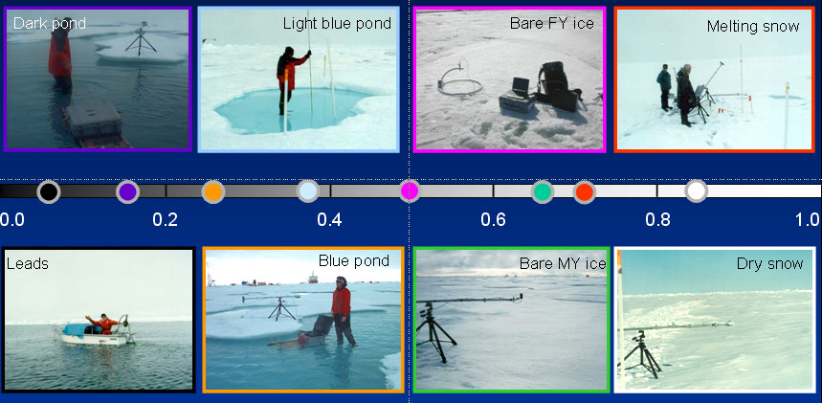
Figure 2. Wavelength-integrated albedos of different snow and ice types.
Figure 3. Spectral albedos of different snow and ice types (same as in Figure 2).

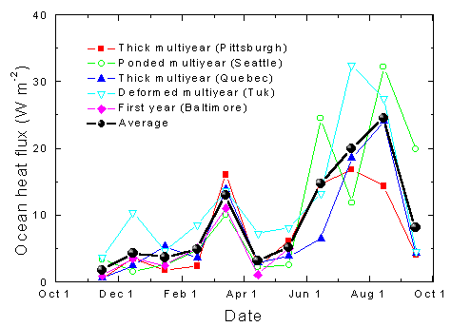
Figure 4. Time series of monthly values of ocean heat flux determined for: thick multiyear ice ponded multiyear ice, ridged multiyear ice, first-year ice, and the average of all sites.

