Math 2210 #5
The Cross Product

The Cross Product
$$\overset{⇀}{u}×\overset{⇀}{v}=\left\langle u_{2}v_{3}-u_{3}v_{2},u_{3}v_{1}-u_{1}v_{3},u_{1}v_{2}-u_{2}v_{1}\right\rangle$$
where $\vec{u}=\left\langle u_{1},u_{2},u_{3}\right\rangle$ and $\vec{v}=\left\langle v_{1},v_{2},v_{3}\right\rangle$.

EX 1
If $\vec{a}=⟨3,3,1⟩$ and $\vec{b}=⟨-2,-1,0⟩$ and $\vec{c}=⟨-2,-3,-1⟩$, find $\vec{a}×(\vec{b}×\vec{c})$.

Theorem A
Let $\vec{u}$ and $\vec{v}$ be 3-D vectors and $θ$ is the angle between them.
Then
- $\vec{u}⋅(\vec{u}×\vec{v})=0=\vec{v}⋅(\vec{u}×\vec{v})$
- $\vec{u},\vec{v}$ and $\vec{u}×\vec{v}$ form a right-handed triple.
- $‖\vec{u}×\vec{v}‖=‖\vec{u}‖‖\vec{v}‖sin⁡θ$
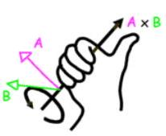

Theorem B
Two 3-D vectors, $\vec{u}$ and $\vec{v}$ are parallel iff $\vec{u}×\vec{v}=0$.

EX 2
Find the plane through these points.
$P_{1}(-1,3,0),P_{2}(5,1,2)$ and $P_{3}(4,-3,-1)$

EX 3
Find the area of a parallelogram with vectors $\vec{a}$ and $\vec{b}$ as adjacent sides.
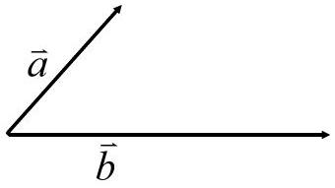

EX 4
Find the volume of a parallelogram prism(box) determined by the sides $\vec{a},\vec{b}$ and $\vec{c}$.
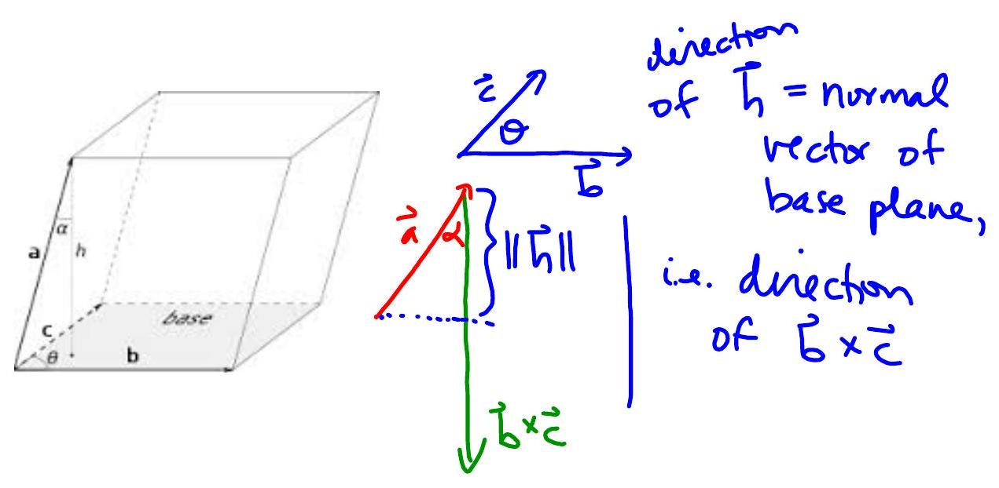

Theorem C Properties of Cross Product
$\vec{u},\vec{v}$ and $\vec{w}$ are 3-D vectors and $k∈R$ :
- $\vec{u}×\vec{v}=-\vec{v}×\vec{u}$
- $u×(v+w)=(\vec{u}×\vec{v})+(\vec{u}×\vec{w})$
- $k(\vec{u}×\vec{v})=(k\vec{u})×\vec{v}=\vec{u}×(k\vec{v})$
- $\vec{u}×\vec{0}=\vec{0}×\vec{u}=\vec{0}$ and $\vec{u}×\vec{u}=\vec{0}$
- $(\vec{u}×\vec{v})⋅\vec{w}=\vec{u}⋅(\vec{v}×\vec{w})$
- $\vec{u}×(\vec{v}×\vec{w})=(\vec{u}⋅\vec{w})\vec{v}-(\vec{u}⋅\vec{v})\vec{w}$
$$\overset{ˆ}{i}×\overset{ˆ}{j}=\overset{ˆ}{k} \overset{ˆ}{j}×\overset{ˆ}{k}=\overset{ˆ}{i} \overset{ˆ}{k}×\overset{ˆ}{i}=\overset{ˆ}{j}$$

EX 5
State whether each of the following expressions make sense or not. If it makes sense, tell if the result is a scalar or a vector.

5a)
$\vec{u}⋅(\vec{v}×\vec{w})$

5b)
$\vec{u}+(\vec{v}×\vec{w})$

5c)
$(\vec{a}⋅\vec{b})×\vec{c}$

5d)
$(\vec{a}×\vec{b}+k)$

5e)
$(\vec{a}+\vec{b})×(\vec{c}+\vec{d})$

5f)
$(\vec{a}⋅\vec{b}+k)$

EX 6
Find the equation of a plane through $(5,-1,2)$ that is perpendicular to the line of intersection of the planes $4x-3y+2z=1$ and $2x-y+z=11$.

