Math 2210 #32
Stokes's Theorem
Remember this form of Green's Theorem:
$${\text{∮} }_{C}\vec{F}⋅d\vec{r}=\iint_{R}{ }∇_{x}\vec{F}⋅\overset{ˆ}{k}dA$$
where
$$\vec{F}(x,y)=M(x,y)\overset{ˆ}{i}+N(x,y)\overset{ˆ}{j},$$
$C$ is a simple closed positively-oriented curve that encloses a closed region, $R$, in the $xy$-plane.
It measures circulation along the boundary curve, $C$.
Stokes's Theorem generalizes this theorem to more interesting surfaces.

Stokes's Theorem
For $\vec{F}(x,y,z)=M(x,y,z)\overset{ˆ}{i}+N(x,y,z)\overset{ˆ}{j}+P(x,y,z)\overset{ˆ}{k}$,
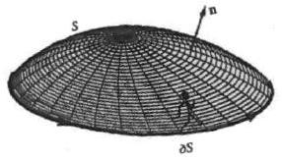
$M,N,P$ have continuous first-order partial derivatives.
$S$ is a 2 -sided surface with continuously varying unit normal, $\overset{ˆ}{n}$,
$C$ is a piece-wise smooth, simple closed curve, positively-oriented that is the boundary of $S$,
$T$ is the unit tangent vector to $C$,
then ${\text{∮} }_{C}\vec{F}⋅\overset{ˆ}{T}ds=\iint_{S}{ }\left(∇×\vec{F}\right)⋅\overset{ˆ}{n}dS$

EX 1
Verify Stokes's Theorem for $\vec{F}=y^{2}\overset{ˆ}{i}-x\overset{ˆ}{j}+5z\overset{ˆ}{k}$ if $S$ is the paraboloid $z=x^{2}+y^{2}$ with the circle $x^{2}+y^{2}=1$ as its boundary.
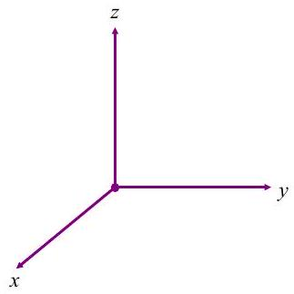

EX 2
Use Stokes's Theorem to calculate $\iint_{S}{ }\left(∇_{x}\vec{F}\right)⋅\overset{ˆ}{n}dS$ for $\vec{F}=xz^{2}\overset{ˆ}{i}+x^{3}\overset{ˆ}{j}+cos⁡(xz)\overset{ˆ}{k}$ where $S$ is the part of the ellipsoid $x^{2}+y^{2}+3z^{2}=1$ below the $xy$-plane and $\overset{ˆ}{n}$ is the lower normal.

EX 3
Let $S$ be a solid sphere. Show that $\iint_{S}{ }\left(∇×\vec{F}\right)⋅\overset{ˆ}{n}dS=0$

3a)
by using Stokes's Theorem

3b)
by using Gauss's Theorem

