Math 1220 #5
Exponential Growth and Decay

Population Growth
Let $y_{0}=$ population at the start.
$dy/dt=ky$ is a reasonable assumption.
I.e. The rate of growth or decay is proportional to the population.

There are other factors that affect population, like resources and land. So population more likely follows a logistic model like this.
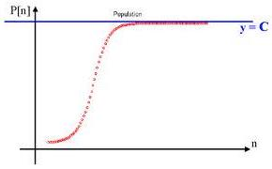

EX 1
The population of the US was 3.9 million in 1790 and 178 million in 1960. If the rate of growth is assumed to be proportional to the population, what estimate would you give for the population in the year 2000? (actual answer = 275 million)

Compound Interest Formula
$$A(t)=A_{0}{\left(1+\frac{r}{n}\right)}^{nt}$$

$A_{0}$ = initial amount
$A(t)=$ value after t years
r = Interest rate
$n=$ number of compounding periods
What if we compound continuously?
$$A(t)=\lim_{n→∞} A_{0}{\left(1+\frac{r}{n}\right)}^{nt}$$

Theorem
$$\lim_{h→0} (1+h)^{\frac{1}{h}}=e$$

Proof

Continuous compounding:

EX 2
Compute this limit to get a formula for continuously compounded interest.

$$A(t)=\lim_{n→∞} A_{0}{\left(1+\frac{r}{n}\right)}^{nt}$$

EX 3
Compute this limit.
$$\lim_{x→∞} {\left(\frac{x+3}{x+1}\right)}^{x}$$

