Math 1060 ~ Trigonometry

8 Graphing Other Trigonometric Functions
$$f(x)=tan⁡x=\frac{sin⁡x}{cos⁡x}$$
Vertical asymptotes:
where $cos⁡x=0$
Period:
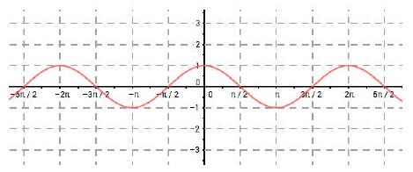

Domain:
Range:
Symmetry:
Increasing/decreasing:

$$f(x)=cot⁡x=\frac{cos⁡x}{sin⁡x}$$
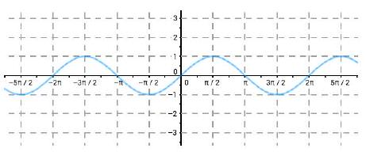
Vertical asymptotes: where $sin⁡x=0$
Period:
Domain:
Range:
Symmetry:
Increasing/decreasing:

$$f(x)=sec⁡x=\frac{1}{cos⁡x}$$
Vertical asymptotes: where $cos⁡x=0$
Period:

Domain:

Range:

Symmetry:

$$f(x)=csc⁡x=\frac{1}{sin⁡x}$$
Vertical asymptotes: where $sin⁡x=0$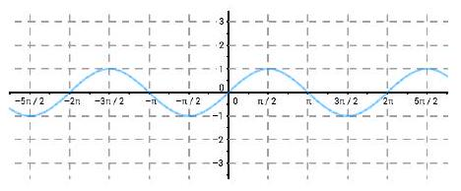
Period:

Domain:

Range:

Symmetry:

EX 1
List the transformations and sketch a graph.
$$f(x)=sec⁡(2x)+1$$
Period:
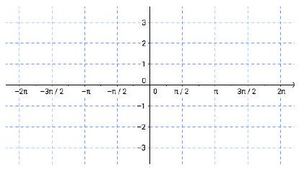
Asymptotes:
Horizontal shift:
Vertical shift:
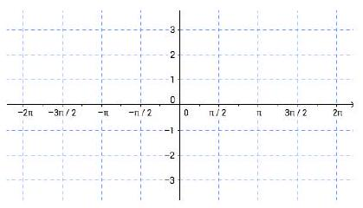

EX 2
List the transformations for this function.
$$f(x)=tan⁡\left(2x-\frac{π}{2}\right)+1$$
Period:
Asymptotes:
Horizontal shift:
Vertical shift:
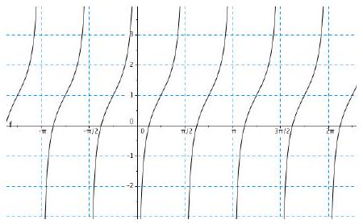

EX 3
See if you can recognize which of the functions are represented in the graphs below.

3a)
Draw the asymptotes and write an equation for each of these graphs, assuming there are no transformations.

3b)
Write each function that is a co-function as a transformation of another function.
