Math 1060 ~ Trigonometry

2 Right Triangles
In this section you will:
- Identify the trigonometric ratios.
${30}^{∘},{45}^{∘}$ and ${60}^{∘}$.
- Solve right triangles and related application problems.

Similar Triangles
Two triangles are similar if they have the same shape, more specifically, if their corresponding angles are congruent. Additionally two triangles are similar if and only if their corresponding sides are proportional.
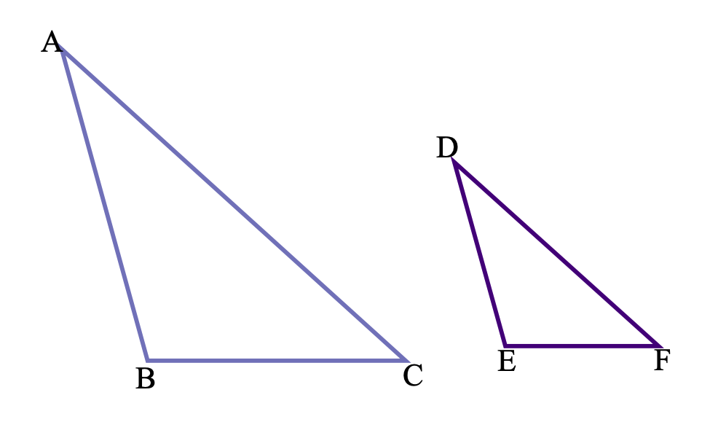

Trigonometric Ratios
Consider this generic right triangle with angle $θ$.
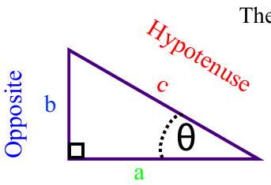
Adjacent
The six trigonometric ratios are:
- $sin⁡(θ)=\frac{\text{ opposite }}{\text{ hypotenuse }}=\frac{b}{c}$
- $cos⁡(θ)=\frac{\text{ adjacent }}{\text{ hypotenuse }}=\frac{a}{c}$
- $tan⁡(θ)=\frac{\text{ opposite }}{\text{ adjacent }}=\frac{b}{a}$
- $cot⁡(θ)=\frac{\text{ adjacent }}{\text{ opposite }}=\frac{a}{b}$
- $sec⁡(θ)=\frac{\text{ hypotenuse }}{\text{ adjacent }}=\frac{c}{a}$
- $csc⁡(θ)=\frac{ \text{hypotenuse} }{ \text{opposite} }=\frac{c}{b}$

Important properties of the trigonometric ratios:
- For all right triangles with the same acute angle $θ$, because they are similar, the values of the resulting trigonometric ratios of $θ$ will be identical.
- Cosecant, secant and cotangent are reciprocal ratios of sine, cosine and tangent respectively.

EX 1
Find the six trigonometric ratios for the angle, $θ$.
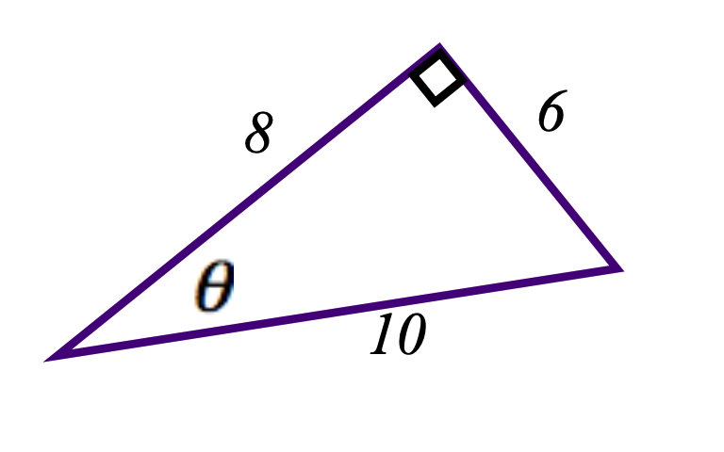

EX 2
Verify that this triangle is similar to the one in example 1 and find the six trigonometric ratios for the angle which corresponds to $θ$.
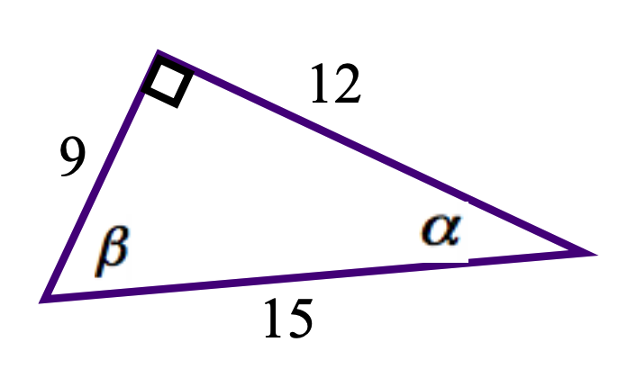

Pythagorean Theorem
The square of the hypotenuse in a right triangle is equal to the sum of the squares of the two shorter sides. For example, in this right triangle, with hypotenuse $c$
$$c^{2}=a^{2}+b^{2}.$$
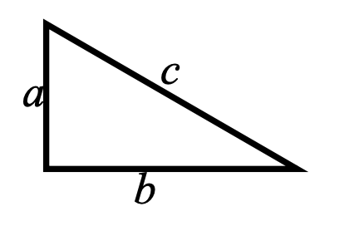

Trigonometric Ratios of ${30}^{∘},{60}^{∘},{90}^{∘}$ Triangles
We begin with an equilateral triangle and cut it in half.
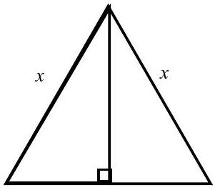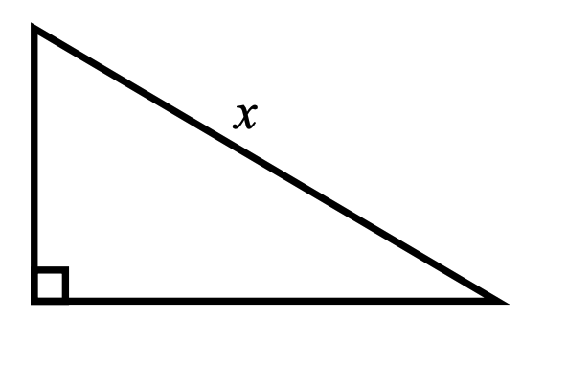

$$sin⁡{30}^{∘}=$$ | $$sec⁡{30}^{∘}=\frac{1}{cos⁡{30}^{∘}}=$$
$$cos⁡{30}^{∘}=$$ | $$csc⁡{30}^{∘}=\frac{1}{sin⁡{30}^{∘}}=$$
$$tan⁡{30}^{∘}=$$ | $$cot⁡{30}^{∘}=\frac{1}{tan⁡{30}^{∘}}=$$

Trigonometric Ratios of ${45}^{∘},{45}^{∘},{90}^{∘}$ Triangles

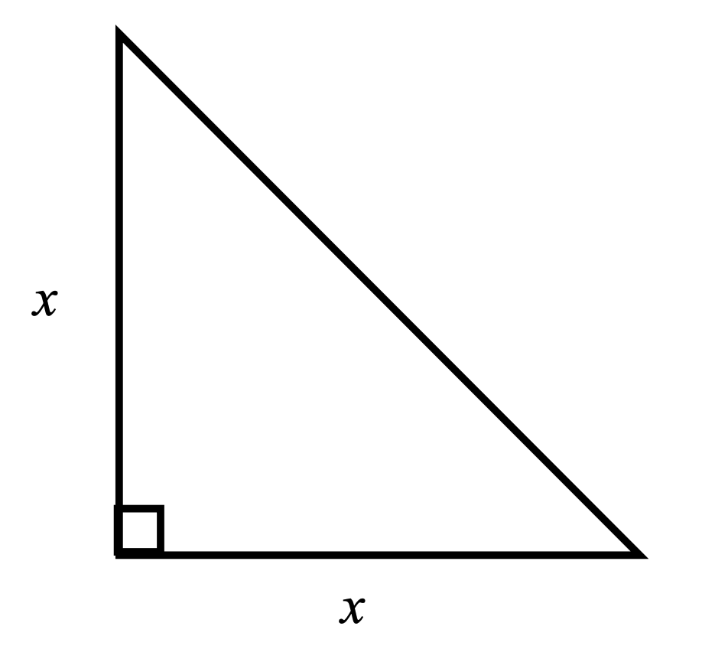
$$sin⁡{45}^{∘}=$$ | $$sec⁡{45}^{∘}=\frac{1}{cos⁡{45}^{∘}}=$$
$$cos⁡{45}^{∘}=$$ | $$csc⁡{45}^{∘}=\frac{1}{sin⁡{45}^{∘}}=$$
$$tan⁡{45}^{∘}=$$ | $$cot⁡{45}^{∘}=\frac{1}{tan⁡{45}^{∘}}=$$

EX 3
Find the missing parts of these right triangles.

$$θ$$ | $$sin⁡θ$$ | $$cos⁡θ$$ | $$tan⁡θ$$
$${30}^{∘}$$ | $$\frac{1}{2}$$ | $$\frac{\sqrt{3}}{2}$$ | $$\frac{\sqrt{3}}{3}$$
$${45}^{∘}$$ | $$\frac{\sqrt{2}}{2}$$ | $$\frac{\sqrt{2}}{2}$$ | 1
$${60}^{∘}$$ | $$\frac{\sqrt{3}}{2}$$ | $$\frac{1}{2}$$ | $$\sqrt{3}$$

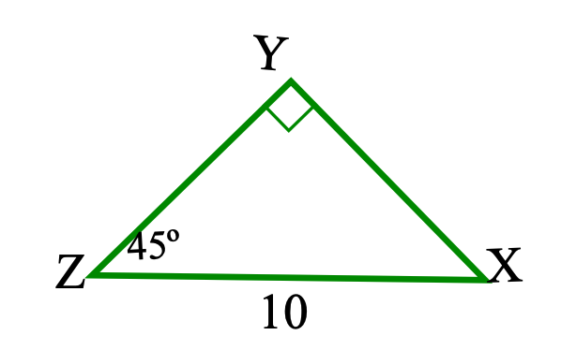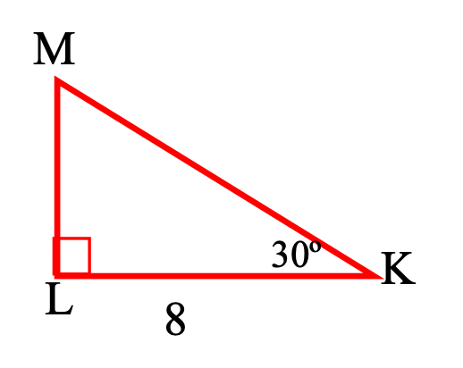
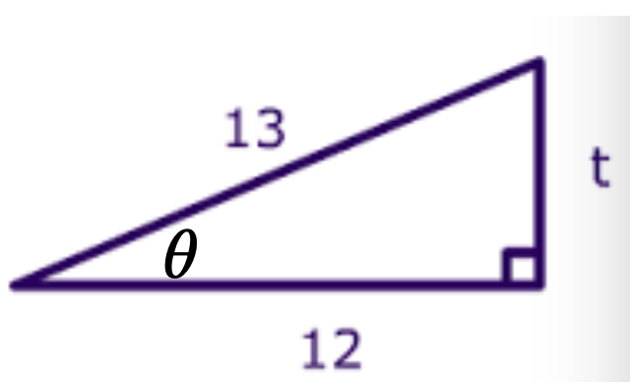

3a)
$x=$

3b)
$z=$

3c)
$k=$

3d)
$l=$

3e)
$t=$

3f)
$sin⁡θ=$

3g)
$sec{θ}=$
3h)
$$tan⁡θ=$$
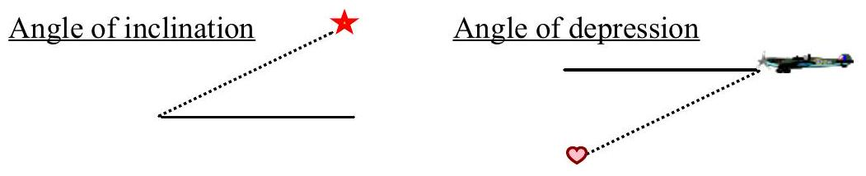

EX 4
The angle of inclination from a point on the ground 40 feet from the base of a tower is ${60}^{∘}$. How tall is the tower?

EX 5
If a 50-foot tight-rope from the corner of the top of a building meets the ground at an angle of ${45}^{∘}$, how tall is the building?

