Math 1060 ~ Trigonometry

27 Conic Sections: Ellipses, Including Circles

EX 1
Given the points $F_{1}(-4,0)$ and $F_{2}(4,0)$, plot several points such that the sum of the distances from $F_{1}$ and $F_{2}$ to each point is 12 . Draw the curve connecting the points.
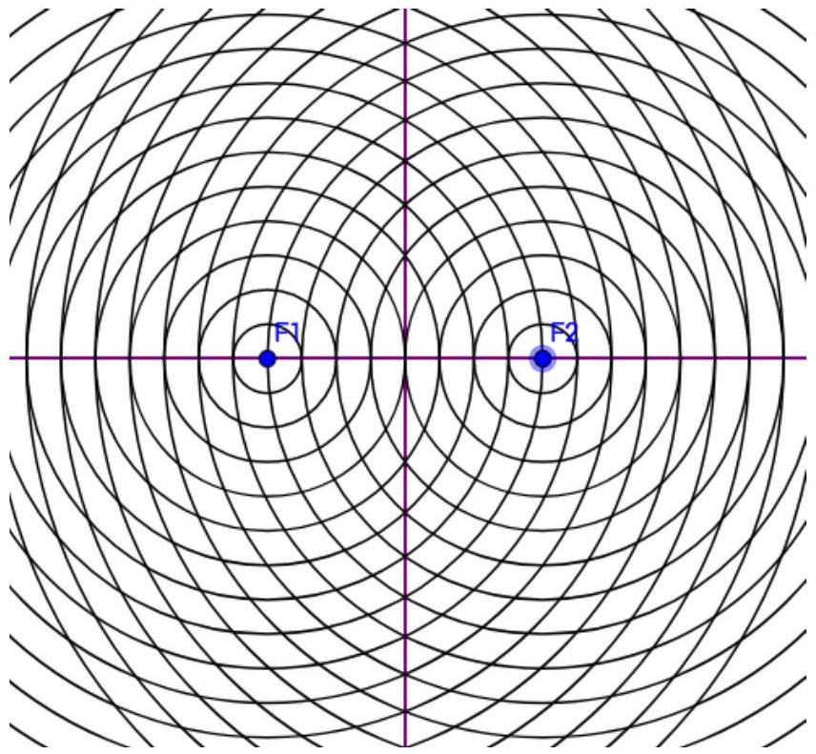

Ellipses
General form: $Ax^{2}+By^{2}+Cx+Dy+E=0$
($A$ and $B$ have same sign)
Given: two points (foci) and a distance (c).

Definition
An ellipse is the set of all points in a plane such that for each point on the ellipse, the sum of its distances from two fixed points is constant.

Vocabulary
Major axis
Minor axis
Center
Foci
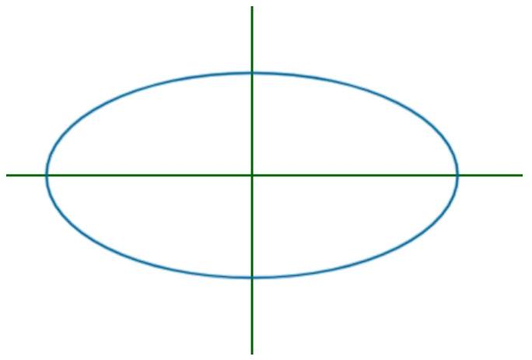

Standard Form of an Equation of an Ellipse with Center at $(0,0)$
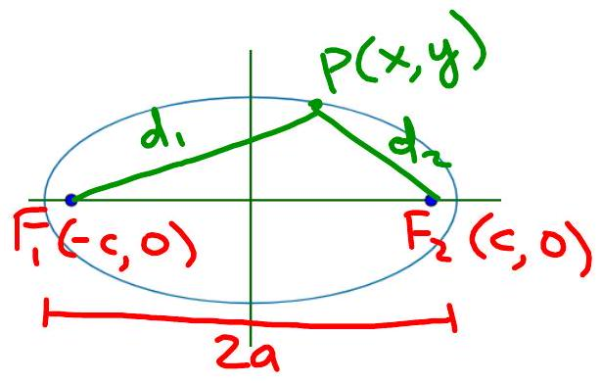
$$d_{1}+d_{2}=2a$$

EX 2
Write the equation of these ellipses in standard form.

2a)
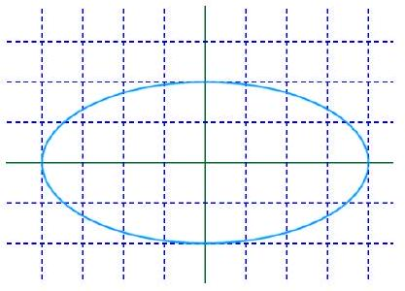

2b)
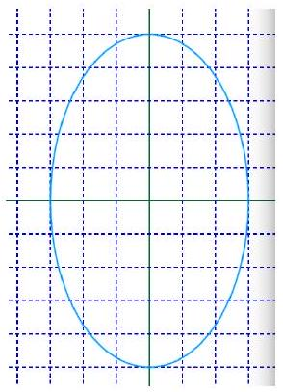

The variables $a,b$ and $c$ have a special relationship.

EX 3
Determine the value of $c$ for each ellipse above and plot the foci.

Translations of an Ellipse

Standard Ellipse | Translated Ellipse
center at $(0,0)$ | center at $(h,k)$

EX 4
Sketch each of these curves and locate the foci.
- $36x^{2}+16y^{2}=576$
- $9(x+2)^{2}+16(y-3)^{2}=144$
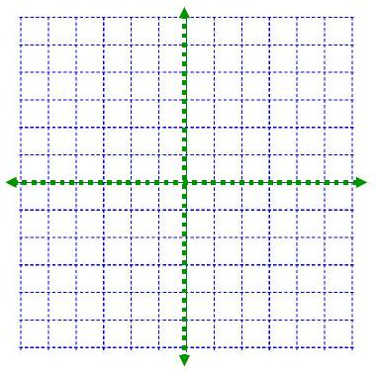

EX 5
Write an equation and sketch each of these.

5a)
An ellipse with center point (-2,3), $a=5,c=3$, longer in the vertical direction.
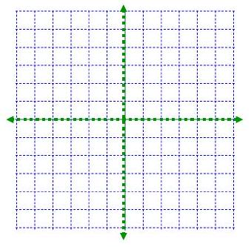

5b)
An ellipse with vertices at (-6,3) and (4,3) and foci at (-4,3) and (2,3)
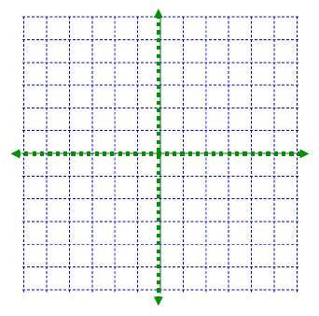

EX 6
Write this equation in standard form, sketch it, including the foci.
$$x^{2}+9y^{2}-4x-18y-14=0$$
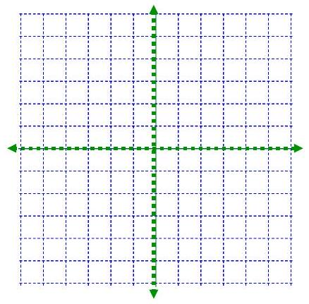

Eccentricity of an Ellipse
$$e=c/a$$

