Math 1060 ~ Trigonometry

26 Conic Sections: Parabolas

Parabolas
A parabola is the set of points of equal distance from a given point and a given line.
The point is called the focus and the line is called the directrix.

EX 1
Plot several points which are equidistant from $F$, the focus and $d$, the directrix.
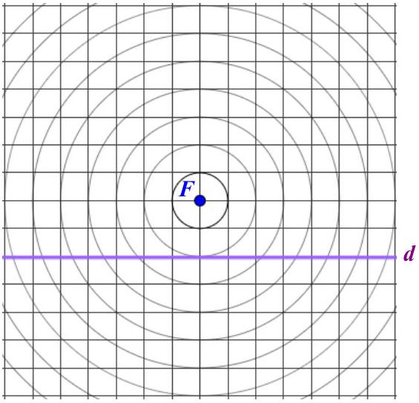

Vocabulary for Parabolas
Focus
Directrix
Axis of symmetry
Latus rectum (focal chord)
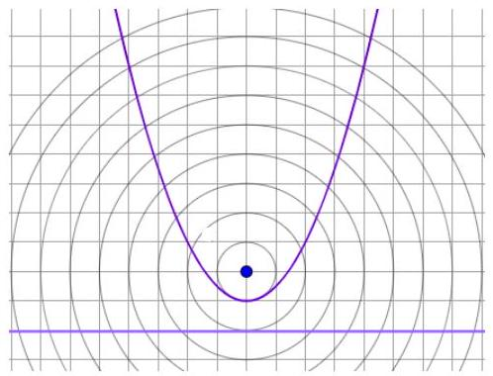

We can develop a formula for the parabola.
Let $(x,y)$ be any point on the parabola.
Let $F$ be at $(0,c)$ and the line $L$ be at $y=-c$.

Standard Form of Parabolas with Vertex at $\left(0,0\right)$
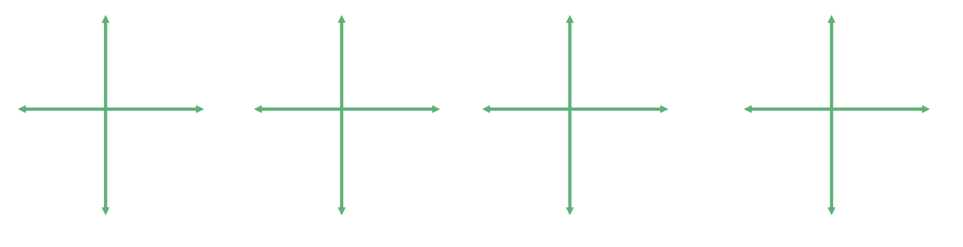

EX 2
Graph each of these.

2a)
$2x^{2}=-4y$

2b)
$3y^{2}-12x=0$
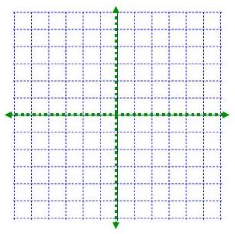

Transformations of a Parabola

EX 3
Graph each of these. You may need to complete the square on one of them to put it in standard form.

3a)
$(x-2)^{2}=2(y-1)$

3b)
$y^{2}-6y=-4x-11$

EX 4
Find the equation of a parabola with the given information.

4a)
directrix at $y=-4$, vertex at $(4,-1)$
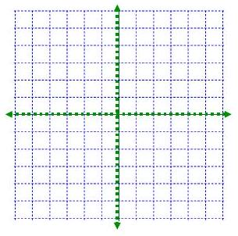

4b)
vertex at (4,2), passing through (-3,-4) with axis parallel to the $x$-axis.
