Math 1060 ~ Trigonometry

21 Vector Properties and Operations
A vector is a directed line segment.
A vector has direction and magnitude independent of the position.
It has a tip and a tail.
It can be named in these ways:
$$\vec{v}$$
$$v$$
$$\overset{⇀}{PQ}$$

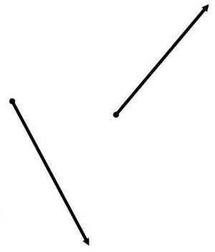
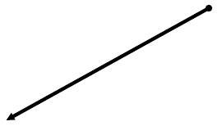

Magnitude and direction of vector $v$

$‖ν‖$ represents the magnitude or length of the vector.
$θ$ represents the direction angle of the vector.
Two vectors are the same if they have the same direction and the same magnitude independent of position.
Opposite vectors have the same magnitude and opposite directions.

EX 1
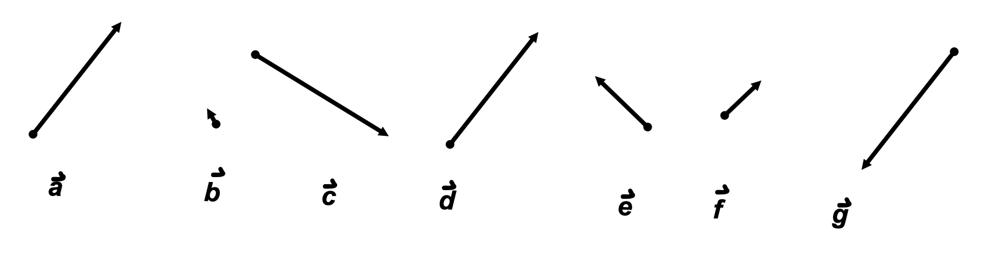

1a)
Select the two equivalent vectors.

1b)
Select the two opposite vectors.

EX 2
State the magnitude and direction of these vectors in standard position.
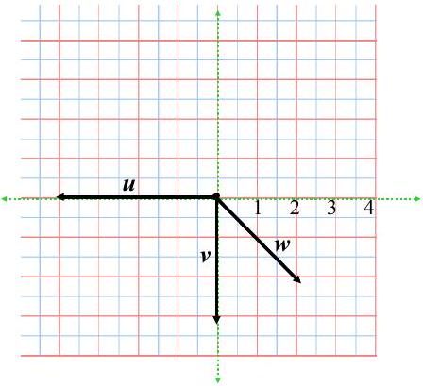

Magnitude and Direction Angle of a Vector
$$v=⟨-2,1⟩$$$‖v‖$ The magnitude of a vector is found using the Pythagorean Theorem on the coordinates of the endpoints of the vector.
$θ$ The direction angle is found with trigonometry by using arctan to find the reference angle, then placing the angle in the correct quadrant.

EX 3
Determine the magnitude and direction angle of the vector, $u=⟨5,-12⟩$.

EX 4
Sketch each of these on the graph below. There are three forms to describe a vector.
Coordinates of tip and tail $PQ$ | Component form in standard position $v=⟨a,b⟩$ | Magnitude, direction angle form $v=‖v‖⟨cos⁡θ,sin⁡θ⟩$
$$P=(-2,1) Q=(3,-4)$$

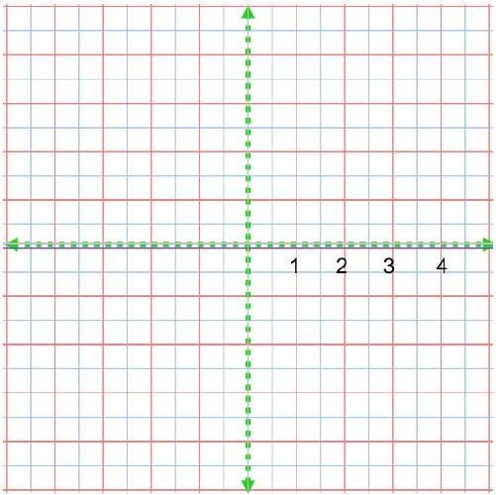

Vector Arithmetic
A vector may be multiplied by a scalar. If $v=⟨a,b⟩$, then $kv=⟨ka,kb⟩$.

EX 5
Perform these operations by components and graphically.
$$u=⟨4,6⟩ v=⟨-2,1⟩$$

5a)
$0.5u=$

5b)
$-3ν=$
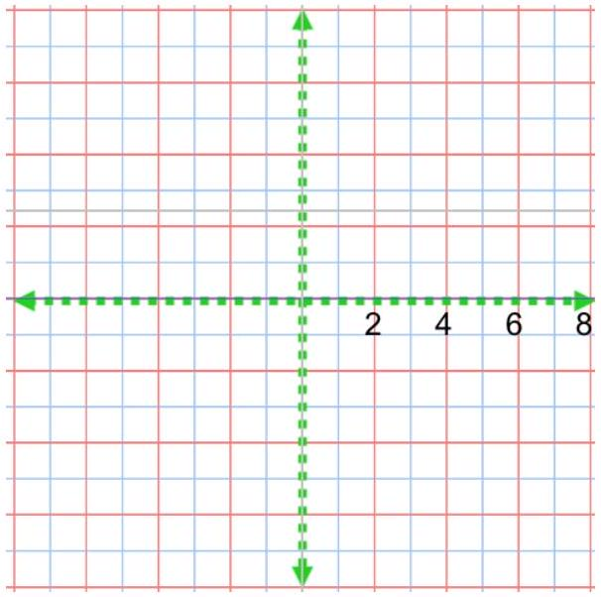

Vector Addition
Vectors may be added by adding their components. When adding two vectors geometrically, place them tail to tip. The resultant is the vector from the tail of the first to the tip of the last.
If $u=⟨a,b⟩$, and $v=⟨c,d⟩$, then $r=u+v=⟨a+c,b+d⟩$.

EX 6
Demonstrate $u-3v$ with components and geometrically.
$$u=⟨3,2⟩ v=⟨-2,1⟩$$
