Math 1060 ~ Trigonometry

19 Trigonometric Representation of Complex Numbers

Review of Complex Numbers
What is $i$?
The rectangular form of a complex number is $z=a+bi$, where $a$ is the real part and $b$ is the imaginary part. This is represented by $Re(z)=a$ and $Im(z)=b$.
This exercise should serve as a review of complex numbers as learned in a previous course.

EX 1
Let $z_{1}=2-2i$ and $z_{2}=-3+4i$.

1a)
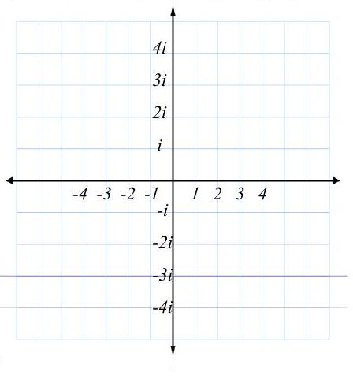
Sketch $z_{1}$ and $z_{2}$ in the complex plane

1b)
$$z_{1}+z_{2}=$$

1c)
$$z_{1}×z_{2}=$$

1d)
$$\overline{z_{l}}=$$

1e)
$$\left|z_{1}\right|=$$

1f)
$${\left(z_{1}\right)}^{2}=$$

You may be asking what is the square root of $i$?

Trigonometric Form (Polar Form) of a Complex Number
$z=a+bi$ becomes $z=r(cos⁡θ+isin⁡θ)=r$ cis $θ$.
- $r=|z|$ and is called the modulus of $z$.
- $θ$ is called the argument of $z$, and $tan⁡θ=\frac{b}{a}$.
$θ$ is the angle when sketched in standard position, on the interval $[0,2π)$.
$\tan^{-1}⁡\left|\frac{b}{a}\right|$ will give you the reference angle.
It is up to you to name the argument in the correct quadrant.
Note that the argument and the modulus are both positive.

EX 2
State the coordinates of these points in rectangular form $(a+bi)$ and in polar form ( $r$ cis $θ$ ) using radians.
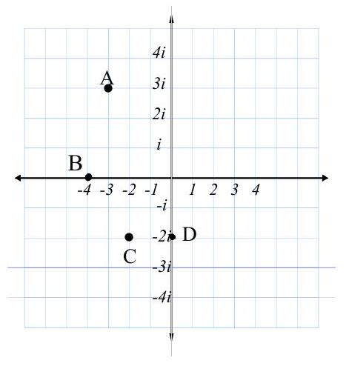

EX 3
Put these in trigonometric (polar) form, $r(cos⁡θ+isin⁡θ)$.

3a)
$z_{l}=2\sqrt{3}-2i$ (radians)

3b)
$z_{2}=-3+4i$ (degrees)

EX 4
Write these in rectangular form, $(a+bi)$.

4a)
$$z_{1}=3\left(cos⁡\frac{5π}{3}+isin⁡\frac{5π}{3}\right)$$

4b)
$$z_{2}=20\left(cos⁡{210}^{∘}+isin⁡{210}^{∘}\right)$$

