Math 1060 ~ Trigonometry

12 Inverse Trigonometric Functions
To find the inverse of the trigonometric functions, our first problem is that they are not one-to-one.
$$y=sin⁡(x)$$ | $$y=\sin^{-1}⁡(x)=arcsin⁡(x)$$
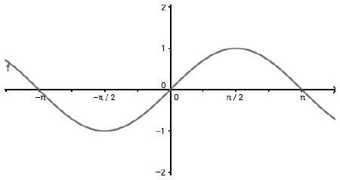 | 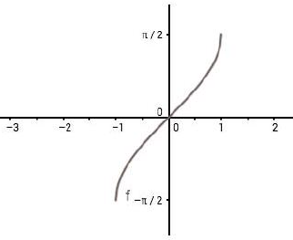
restricted domain: | domain:
range: | range:
symmetry: | symmetry:
does $sin⁡\left(\sin^{-1}⁡(x)\right)=x$? | does $\sin^{-1}⁡(sin⁡(x))=x$?

$$y=cos⁡(x)$$ | $$y=\cos^{-1}⁡(x)=arccos⁡(x)$$
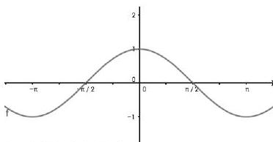 | 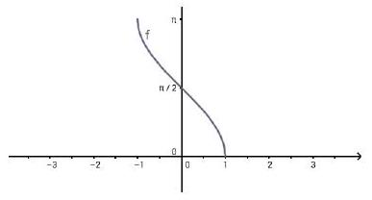
restricted domain: | domain:
range: | range:
symmetry: | symmetry:
does $cos\left(\cos^{-1}⁡(x)\right)=x$? | does $\cos^{-1}⁡(cos⁡(x))=x$?

$$y=tan⁡(x)$$ | $$y=\tan^{-1}⁡(x)=arctan⁡(x)$$
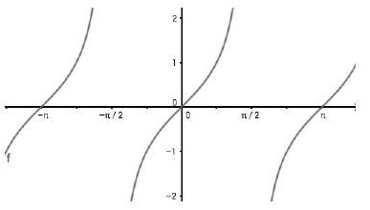 | 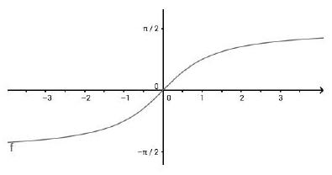
restricted domain: | domain:
range: | range:
symmetry: | symmetry:
does $tan⁡\left(\tan^{-1}⁡(x)\right)=x$? | does $\tan^{-1}⁡(tan⁡(x))=x$?

When working these problems, it is easier if you think of the Unit Circle rather than the Cartesian graph.
$\sin^{-1}⁡(x)$ answers will be in the interval $\left[-\frac{π}{2},\frac{π}{2}\right]$
$\cos^{-1}⁡(x)$ answers will be in the interval $[0,π]$
$\tan^{-1}⁡(x)$ answers will be in the interval $\left(-\frac{π}{2},\frac{π}{2}\right)$

Note that to compute the $\sec^{-1}⁡(x),\csc^{-1}⁡(x)$ and $\cot^{-1}⁡(x)$ you can turn each into a problem involving the three functions above.

EX 1
Look at a Unit Circle and practice by finding the answers to these:

1a)
$$\sin^{-1}⁡\left(\frac{\sqrt{3}}{2}\right)$$

1b)
$$\cos^{-1}⁡\left(\frac{\sqrt{2}}{2}\right)$$

1c)
$$\tan^{-1}⁡\left(-\frac{1}{\sqrt{3}}\right)$$

1d)
$$\sin^{-1}⁡\left(-\frac{1}{2}\right)$$

1e)
$$\sec^{-1}⁡\left(-\frac{2}{\sqrt{3}}\right)$$

1f)
$$\tan^{-1}⁡(-1)$$

EX 2
Try these without looking at a Unit Circle.

2a)
$$\sin^{-1}⁡(-1)$$

2b)
$$\cos^{-1}⁡(0)$$

2c)
$$\tan^{-1}⁡(1)$$

2d)
$$\csc^{-1}⁡(0)$$

2e)
$$\sec^{-1}⁡(-2)$$

2f)
$$\cot^{-1}⁡(-1)$$

EX 3
Which of these are true? Correct any that are false.

3a)
$$\sin^{-1}⁡\left(sin⁡\left(\frac{3π}{4}\right)\right)=\frac{3π}{4}$$

3b)
$cos⁡\left(\cos^{-1}⁡\left(\frac{1}{2}\right)\right)=\frac{1}{2}$

3c)
$$\tan^{-1}⁡(tan⁡π)=π$$

EX 4
These will require a bit more thought and perhaps a drawing of a triangle.
Evaluate these.

4a)
$$cos⁡\left(arctan⁡\left(\frac{2}{3}\right)\right)$$

4b)
$$tan⁡\left(\sin^{-1}⁡\left(\frac{3}{4}\right)\right)$$

4c)
$$sec⁡\left(\cos^{-1}⁡\left(\frac{3x}{2}\right)\right)$$

EX 5
Evaluate these.

5a)
$$sec⁡\left(arctan⁡\left(-\frac{3}{4}\right)\right)$$

5b)
$$cot⁡\left(\sin^{-1}⁡(-0.2)\right)$$

EX 6
Here is another challenge. Evaluate these.

6a)
$$sec⁡\left(arctan⁡\left(-\frac{3}{4}\right)\right)$$

6b)
$$cot⁡\left(\sin^{-1}⁡(-0.2)\right)$$

EX 7
A plane flies at an altitude of 6 miles toward a point directly over an observer. Write the angle $θ$ as a function of x , the horizontal distance from the observer to a point on the ground directly below the airplane.

