Logistic regression and a classification and regression tree (CART) were each used to create a tool for predicting survival to hospital discharge in children receiving extracorporeal membrane oxygenation. Both tools were applied to a cohort of 571 children. The results are displayed in the table below. For example, there were 183 subjects for whom both tools correctly predicted survival and 34 subjects for whom both tools incorrectly predicted survival. Determine if one of the tools is better than the other by testing the null hypothesis that neither is more likely to provide better prediction. Identify all three possible alternative hypotheses and report the p-value for each. Discuss your findings.

Survival predicted by logistic regression model | Survival predicted by CART | Subject actually survived | Number of subjects
Yes | Yes | Yes | 183
Yes | Yes | No | 34
Yes | No | Yes | 37
Yes | No | No | 15
No | Yes | Yes | 18
No | Yes | No | 10
No | No | Yes | 61
No | No | No | 213

Solution: We will use the sign test. Exclude all cases where both tools predicted the same outcome. The test statistic is the number of disagreements where CART predicted correctly. That is, t = 33. Since there were 80 disagreements, under the null hypothesis, T ~ BIN(80,1/2).
For the alternative that CART is better, p-value = 1-pbinom(size=80, prob=1/2, 32) = 0.9535441.
For the alternative that CART is worse, p-value = pbinom(size=80, prob=1/2, 33) = 0.07281773
For the alternative that one of them is better than the other, p-value = 2* pbinom(size=80, prob=1/2, 33) = 0.1456355.

In a study of 376 children hospitalized for community-acquired septic shock, health-related quality of life was measured prior to hospitalization (baseline) and then at 7 days, 1 month, 3 months, 6 months, and 12 months after admission to the hospital. The Pediatric Quality of Life Inventory (PedsQL) was used to assess quality of life at each timepoint. One of the questions in the PedsQL is ‘Does your child have hurts or aches (pain)?’ The five response options for the question are never, almost never, sometimes, often, almost always. Researchers were interested to know if children had residual pain after sepsis, and, if so, how long it lasts. The table below shows the distribution of responses by timepoint and indicates that there is residual pain for at least 3 months following hospitalization for sepsis.
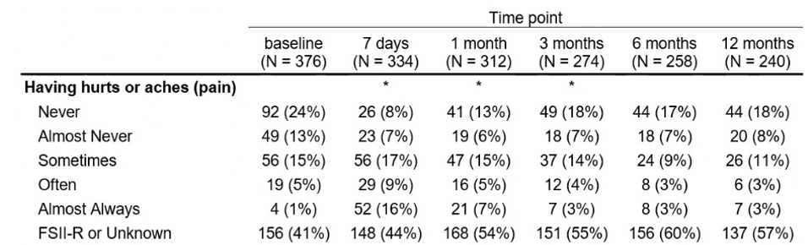
* Test comparing pain at follow-up compared to baseline is significant at α = 0.05.
Consider a hypothetical repeat of this study with the following data. Determine if there is residual pain at 1 month. Identify all three possible alternative hypotheses and report the p-value for each. Discuss your findings.
 | Having hurts or aches (pain) at 1 month
Having hurts or aches (pain) at baseline | Never | Almost Never | Sometimes | Often | Almost Always
Never | 4
Almost Never | 1 | 10 |  |  | 1
Sometimes |  |  | 4 |  | 2
Often |  |  |  | 7
Almost Always |  |  |  |  | 3

Solution: We’ll use the signed rank test for this. Exclude cases where pain at 1 month is the same as baseline. The test statistic will be the sum of ranks of positive differences (i.e. more pain at 1 month than follow-up)
4 | 2.5 | 2.5 | 1 | t
+ | + | + | + | 10
+ | + | + |  | 9
+ | + |  | + | 7.5
+ | + |  |  | 6.5
+ |  | + | + | 7.5
+ |  | + |  | 6.5
+ |  |  | + | 5
+ |  |  |  | 4
 | + | + | + | 6
 | + | + |  | 5
 | + |  | + | 3.5
 | + |  |  | 2.5
 |  | + | + | 3.5
 |  | + |  | 2.5
 |  |  | + | 1
 |  |  |  | 0

For the alternative that residual pain exists, p-value =2/16.
For the alternative that pain is lessened after sepsis, p-value = 15/16.
For the alternative that pain is changed after sepsis, p = 4/16.

The pediatric cerebral performance category (PCPC) is a scale from 1 (normal) to 6 (brain dead) that is used to measure neurologic outcome following cardiopulmonary resuscitation. Epinephrine (adrenaline), is a drug commonly used during resuscitation to raise diastolic blood pressure. Higher diastolic blood pressure is believed to be associated with better neurologic outcome. In a hypothetical study of 7 subjects receiving cardiopulmonary resuscitation, 5 received epinephrine and 2 did not.
The diastolic blood pressures of the 5 who received epinephrine were 20, 23, 26, 28, 30; and the diastolic blood pressures of the 2 subjects who did not receive epinephrine were 15 and 21. Test whether epinephrine changes blood pressure. Identify all three possible alternative hypotheses and report the p-value for each. Discuss your findings.

1 | 2 | 3 | 4 | 5 | 6 | 7 | t
x | x |  |  |  |  |  | 3
x |  | X |  |  |  |  | 4
x |  |  | x |  |  |  | 5
x |  |  |  | X |  |  | 6
x |  |  |  |  | X |  | 7
x |  |  |  |  |  | X | 8
 | x | X |  |  |  |  | 5
 | x |  | X |  |  |  | 6
 | x |  |  | x |  |  | 7
 | x |  |  |  | X |  | 8
 | x |  |  |  |  | X | 9
 |  | x | x |  |  |  | 7
 |  | x |  | X |  |  | 8
 |  | x |  |  | X |  | 9
 |  | x |  |  |  | X | 10
 |  |  | X | X |  |  | 9
 |  |  | x |  | X |  | 10
 |  |  | x |  |  | X | 11
 |  |  |  | x | X |  | 11
 |  |  |  | x |  | X | 12
 |  |  |  |  | x | x | 13

For the alternative that epinephrine increases blood pressure, p = 2/21
For the alternative that epinephrine decreases blood pressure, p = 20/21
For the alternative that epinephrine changes blood pressure, p = 4/21

The PCPC scores for the 5 receiving epinephrine were 1, 2, 2, 2, 3; and the PCPC scores of the two subjects not receiving epinephrine were 2 and 3. Test whether epinephrine is associated with neurologic outcome. Identify all three possible alternative hypotheses and report the p-value for each. Discuss your findings.

1 | 3.5 | 3.5 | 3.5 | 3.5 | 6.5 | 6.5 | t
x | x |  |  |  |  |  | 4.5
x |  | X |  |  |  |  | 4.5
x |  |  | x |  |  |  | 4.5
x |  |  |  | X |  |  | 4.5
x |  |  |  |  | X |  | 7.5
x |  |  |  |  |  | X | 7.5
 | x | X |  |  |  |  | 7
 | x |  | X |  |  |  | 7
 | x |  |  | x |  |  | 7
 | x |  |  |  | X |  | 10
 | x |  |  |  |  | X | 10
 |  | x | x |  |  |  | 7
 |  | x |  | X |  |  | 7
 |  | x |  |  | X |  | 10
 |  | x |  |  |  | X | 10
 |  |  | X | X |  |  | 7
 |  |  | x |  | X |  | 10
 |  |  | x |  |  | X | 10
 |  |  |  | x | X |  | 10
 |  |  |  | x |  | X | 10
 |  |  |  |  | x | x | 13

For the alternative that epinephrine improves PCPC, p = 20/21
For the alternative that epinephrine worsens PCPC, p = 9/21
For the alternative that epinephrine changes PCPC, p = 18/21

In a hypothetical study of 1000 subjects receiving cardiopulmonary resuscitation, 800 received epinephrine and 200 did not. The average diastolic blood pressure in those groups were 28 and 32 mmHg, respectively. The standard deviations can reasonably be assumed to be the same in both groups and was estimated from the sample to be 10 mmHg. Test the whether epinephrine is associated with diastolic blood pressure. Identify all three possible alternative hypotheses and report the p-value for each. Discuss your findings.

A certain drug is administered transcutaneously from a patch. 60 subjects participate in a trial of the patch designed to demonstrate that two versions of the patch are bioequivalent. Each participant tries one patch formulation and then, a week later, tries the other formulation. To show bioequivalence, the area under the drug concentration versus time curve was measured for each subject over 96 hours. The natural log of the area under the curve is assumed for theoretical reasons to be normally distributed. If the average of the ln(AUC) from patch formation 1 is 20 and the average of the ln(AUC) form patch formulation 2 is 21, test the null hypothesis that difference in means of the logs is ln(1.25) against the alternative that it is less. Now test the null hypothesis that difference in means of the logs is -ln(1.25) against the alternative that it is more. If you reject both null hypotheses, then you conclude bioequivalence. The is called a two one-sided testing procedure.

