Name
Suppose 100 students from the University of Utah will participate in an NZT trial. Each student will take an IQ test without NZT and then again on a different day with NZT. For simplicity, suppose we know that the true standard deviation of differences is 10. Using a two-sided alternative to test the null hypothesis that NZT does not improve IQ, find the power of the test if NZT actually improves IQ by 1 point (on average). Note that this is all calculated prior to conducting the experiment.

(11.19 in the textbook)
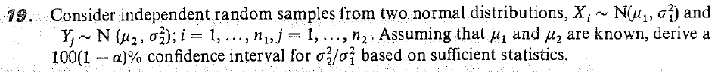

(12.19a in the textbook)

Suppose you have an EXP(θ, η) population. Derive a GLR test of the null hypothesis that θ = 4 against the alternative that θ > 4. Write down the test statistic and all associated maximum likelihood estimates. Then state the condition under which you will reject the null hypothesis in order to have a test of approximate size 0.05.

The following table shows the number of m&ms of each type and color that were eaten by 3rd graders in an experiment.
 | Red | Blue | Green | Yellow
Peanut | 13 | 17 | 11 | 16
Peanut butter | 14 | 19 | 14 | 15
Almond | 15 | 16 | 17 | 19
Plain | 13 | 17 | 17 | 16

Test whether there is a relationship between type and color of m&m. In particular, what is the expected count of red peanut m&ms, and what is the p-value? You don’t need to write out the entire test statistic.

The following table shows the number of m&ms of each type and color that were eaten by 3rd graders in an experiment.
 | Red | Blue | Green | Yellow
Peanut | 13 | 17 | 11 | 16
Peanut butter | 14 | 19 | 14 | 15
Almond | 15 | 16 | 17 | 19
Plain | 13 | 17 | 17 | 16

Test whether there the proportion of blue m&ms is the same for Plain and Peanut m&ms. In particular, what is the expected count of plain blue m&ms, and what is the p-value? You don’t need to write out the entire test statistic.

Circle only the statements that are true. You will get 1 point for 6 correct answers; 2 points for 7 correct; 3 points for 8 correct; 4 points for 9 correct. In other words, you will get max(# correct – 5, 0) points for this problem.
- The outcome of a random interval that contains the parameter of interest with 95% probability is called a confidence interval for the parameter of interest.
- If two researchers use the exact same data from an experiment and report different confidence intervals for the same parameter, then they may both be right.
- A one-sided upper confidence interval is most appropriate when a drug company wants to establish (with 95% confidence) that no more than 5% of people will have an allergic reaction to a birth control patch that they are developing.
- MLE – θ is a pivotal quantity for θ if MLE is a maximum likelihood estimator for θ and θ is a location parameter.
- Pivotal quantities are functions of the random sample and the parameter of interest.
- If (1, 2) is a 95% confidence interval for μ, then (1, 4) is a 95% confidence interval for μ².
- If the null hypothesis is not rejected, then you should conclude that the alternative hypothesis is plausible.
- The Neyman-Pearson lemma provide a method to obtain the most powerful test of a simple null hypothesis against a two-sided alternative.
- The generalized likelihood ratio test provides a reasonable test, whose test statistic is the likelihood ratio, and whose distribution under the null hypothesis is χ²(r), where r parameters are fixed under the null.

