Name:
Quiz 9, Attempt 1
200 people were assessed for Race and the presence of a certain characteristic. The following data were collected.
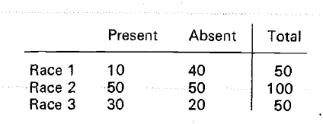
Test the null hypothesis that the proportion of people with the characteristic present is 0.25 for Race 1 and 0.50 for Races 2 and 3. Express your answer as a p-value in terms of a known distribution. Be sure to write down the outcome of the test statistic, but you don’t need to simplify it.

Quiz 7, Attempt 2
Suppose a population has a BER(p) distribution. What is the p-value based on the uniformly most powerful test of H₀: p = ¾ against the alternative that p ≠ 3/4? State what the test statistic is and report your answer in terms of the test statistic OR state that no uniformly most powerful test exists.

