Given a random sample of size 100 with sample variance of 2 and sample mean of 3 from a N(μ, σ²) population, give an 80% equal tailed confidence interval for σ² by doing the following steps.
Write an appropriate probability statement.

Rewrite the statement to isolate σ².

Write the random interval.

Write the outcome of the random interval (i.e. confidence interval)

Express your answer as: Reject the null hypothesis when [test statistic] is [larger/smaller] than [threshold]. Be sure to explicitly state any MLEs you are using.

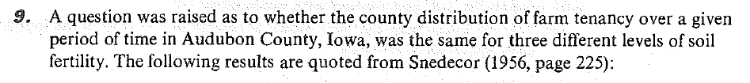
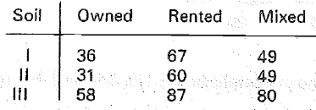
Test the hypothesis that ownership status is independent of soil fertility. The specific things I’m looking for are
- The expect cell count for Soil I, Owned (just this one cell); AND

- The form of the test statistic; AND

- The p-value, as a function of the test statistic.

You do not need to actually go through all the work of computing the outcome of the test statistic.
RAT intelligence is measured before and after NZT in three rats with the following observed values:
Rat ID | IQ before | IQ after
1 | 1 | 3.5
2 | 5 | 4
3 | 3 | 7

One test that could be used is the randomization/permutation test. Name two other tests that are appropriate to determine if NZT works to improve intelligence (IQ)?

Compute the p-value for the two tests you listed, with two-sided alternatives. This counts as two problems and is worth a total of 4 points. Do one test on this page and one on the next page. Do the one whose name comes first (alphabetically) on this page.
Name of test 1:
P-value:

Name of test 2:

P-value:
Redo the previous problem, but assume that 6 rats were used—3 with NZT and three without.
IQ  (NZT group) | IQ (Placebo group)
1 | 3.5
5 | 4
3 | 7

A randomization/permutation test could be used. Name one other test that is appropriate to determine if NZT works to improve intelligence (IQ)?

Compute the p-value for the test you listed. Use a two-sided alternative.

The following code (which uses robust error estimates) was run:
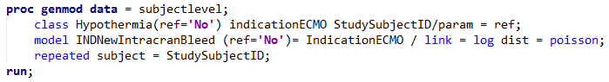
The following output was generated from the above code:
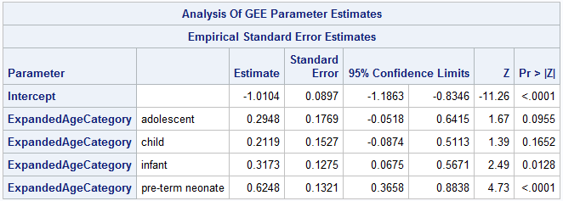
What type of regression is this?

The dataset used comes from a study of 514 children receiving extracorporeal membrane oxygenation. The outcome of the model is bleeding (1=yes, 0=no). Interpret the relationship between the age group and risk of bleeding. In particular compare pre-term neonates to full-term neonates in terms of their risk of bleeding. Note that age category has five levels: pre-term neonate, full-term neonate, infant, child, and adolescent. If you have questions, ask.

The following code was run:
The following output was generated from the above code:
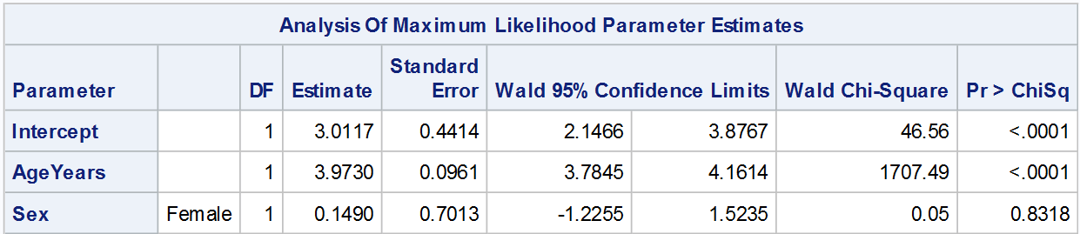
What type of regression is this?

What method was used to estimate the parameters in the model?

Interpret the relationship between the age and weight for females.

What is the expected weight of a 3-year-old male?

