Name:
Quiz 20, Attempt 2
The follow code was run. Hypothermia is 1 of a subject was treated with therapeutic hypothermia and 0 if not. The event (outcome) being modeled is a new intracranial bleed. INDNewIntracranBleed is 1 if the subject experienced a new intracranial bleed and 0 if not.
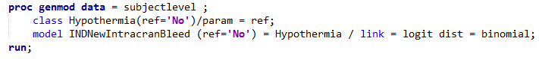

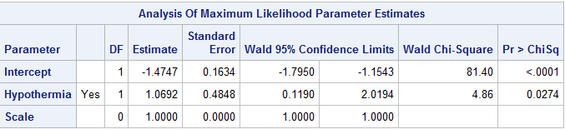
The code produced the following output.

What type of a model is this?

Interpret the results.

Quiz 19, Attempt 2
Suppose IQ and age in Vulcans follows the following model:
IQi = β0 + β1⋅ Agei + ϵi
where Age is measured in Vulcan years.
Explain what it means if β1 is -2.

