Name:
Quiz 20, Attempt 1
The follow code was run. Hypothermia is 1 of a subject was treated with therapeutic hypothermia and 0 if not. The event (outcome) being modeled is a new intracranial bleed. INDNewIntracranBleed is 1 if the subject experienced a new intracranial bleed and 0 if not.
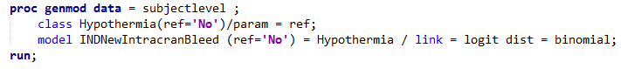

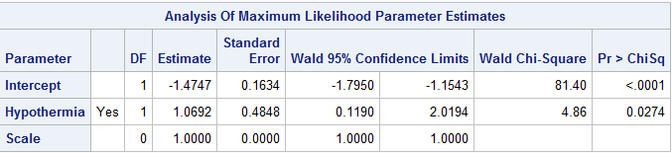
The code produced the following output.

What type of a model is this?

Interpret the results.
Quiz 18, Attempt 2
Suppose you observe IQs of 88, and 95 from a group that did not take NZT. Suppose you also observe IQs of 90 and 110 from a group that did take NZT. Compute the p-value based on a randomization test with the difference of sample means as the test statistic (NZT – Placebo). Assume a two-sided alternative.

