Name:
Quiz 16, Attempt 1
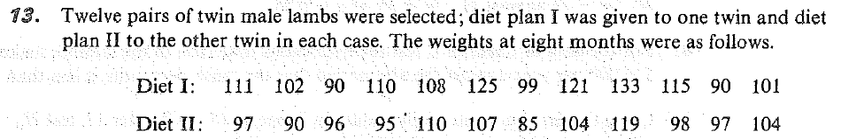
Compute the outcome of the test statistic for the paired signed-rank test that could be used to assess the null hypothesis that differences are symmetric around zero.

Quiz 14, Attempt 2
Certain airplane components failures may be classified as mechanical, electrical or otherwise. Two airplane designs are under consideration, and it is desired to test the hypothesis that the type of failure is independent of the airplane design. Find the p-value in terms of an appropriate distribution.
