Name:
Quiz 15, Attempt 1
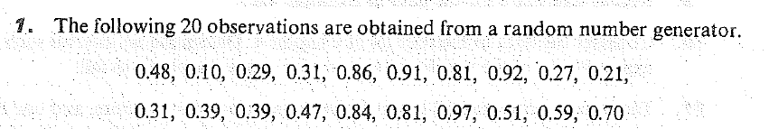
Test the null that the median is 0.4 against the alternative that it is less than 0.4. Find the p-value.

Quiz 13, Attempt 2
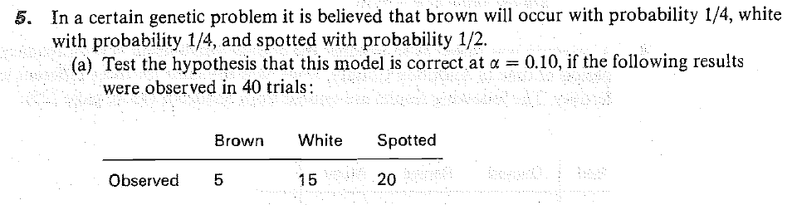
Write down the p-value in terms of the appropriate distribution.

