Name:
Quiz 14, Attempt 1
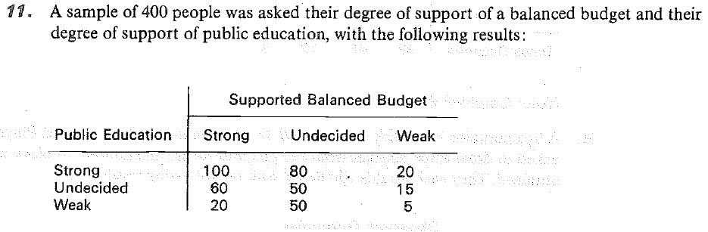
Test the hypothesis that public education support and balanced budget support are independent. Find the p-value in terms of an appropriate distribution.

Quiz 12, Attempt 2

