Name:
Quiz 13, Attempt 1
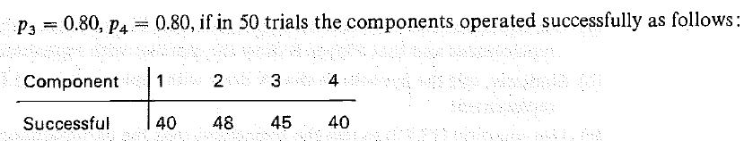
Write down the p-value in terms of the appropriate distribution.

Quiz 11, Attempt 2
