Name:
Quiz 12, Attempt 1
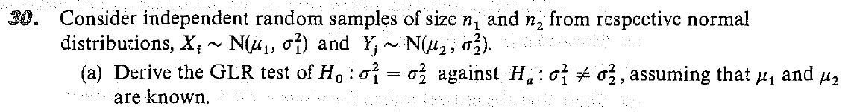

Quiz 10, Attempt 2
