Name:
Quiz 11, Attempt 1
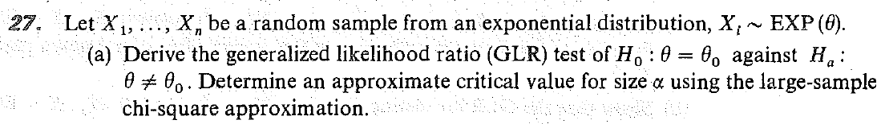

Quiz 9, Attempt 2
What does it mean for a test to be ‘the most powerful test of size alpha?’

Define Type II error and give an example; be sure to indicate the null and alternative hypotheses in your example.

