Name:
Quiz 10, Attempt 1
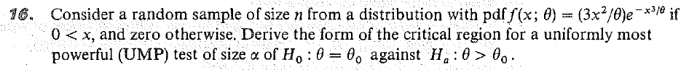

Quiz 8, Attempt 2
Duracell claims that their new batteries hold at least 6.4 amp hours. Assume that the number of amp hours of these new batteries is normally distributed with unknown mean and variance. You have just enough cash in your pocket to purchase 85 of these new batteries. You wish to test Duracell’s claim by determining if the claim is consistent with observed data. You determine that a type I error rate of 0.05 is appropriate. If the true mean is 5, what is the power of the test? Use the sample mean as the test statistic.

