Name:

Question 1 (11.1a in the textbook)
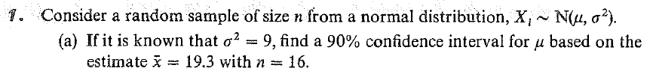
Note that z_{0.95} = 1.645, t_{0.95}(15) = 1.753, t_{0.95}(16) = 1.746, t_{0.95}(17) = 1.740, χ²_{0.95}(15) =24.996 , χ²_{0.95}(16) = 26.296, χ²_{0.95}(17) = 27.587.

Question 2 (11.19 in the textbook)
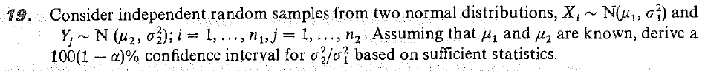

Question 3 (12.19a in the textbook)

Question 4 (12.30a from the textbook)
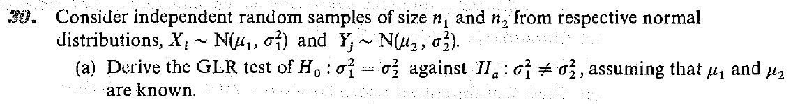

Question 5
Circle only the statements that are true. You will get 1 point for 6 correct answers; 2 points for 7 correct; 3 points for 8 correct; 4 points for 9 correct. In other words, you will get max(# correct – 5, 0) points for this problem.
- A random interval that contains the parameter of interest with 95% probability is called a confidence interval for the parameter of interest.
- If two researchers use the exact same data from an experiment and report different confidence intervals for the same parameter, then one or both of them has made a mistake.
- A two-sided equal-tailed confidence interval is most appropriate when a drug company wants to establish (with 95% confidence) that no more than 5% of people will have an allergic reaction to a birth control patch that they are developing.
- MLE – θ is a pivotal quantity for θ if MLE is a maximum likelihood estimator for θ and θ is a scale parameter.
- Pivotal quantities are sometimes functions of the random sample but not the parameter of interest.
- If (1, 2) is a 95% confidence interval for μ, then (1, 4) may sometimes not be a 95% confidence interval for μ².
- If the null hypothesis is not rejected, then you should conclude that the alternative hypothesis is plausible.
- The Neyman-Pearson lemma provide a method to obtain the most powerful test of a simple null hypothesis against a two-sided alternative.
- The generalized likelihood ratio test provides a reasonable test, whose test statistic is the likelihood ratio, and whose distribution under the null hypothesis is χ²(r), where r parameters are fixed under the null.
