What type of regression model is this?
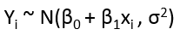

What type of regression model is this?

What type of distribution is this?
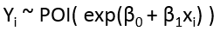

What distribution does Y_{i} have in simple linear regression? Express as a function of x_{i}.

What distribution does Y_{i} have in logistic regression? Express as a function of x_{i}.

What distribution does Y_{i} have in Poisson regression? Express as a function of x_{i}.

Suppose both predictor and outcome are interval variables. What type of regression might be appropriate?

Suppose the predictor is nominal with 5 levels and the outcome is interval. What type of regression might be appropriate? How many binary ‘dummy’ predictors will be needed in the model?

Suppose the outcome is binary but the predictor interval. What type of regression might be appropriate?

Suppose the outcome and predictor are both binary. What type of regression might be appropriate?

When using Poisson regression for binary outcomes, why must ‘robust error estimates’ be used?

What regression model might be appropriate for this data? Specify the distribution of Y as a function of x.
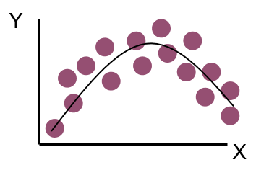

What regression model might be appropriate for this data? Specify the distribution of Y as a function of x.
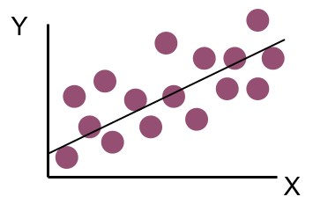

True or false: Predictors must be normally distributed for simple linear regression.
True or false: A histogram of the outcomes should be approximately normally distributed in order to use simple linear regression?

Name at least one way that the parameters could be estimated for a regression model.

Why do researchers often not provide the estimate or confidence interval for the intercept in their models?

What is wrong with the following residuals for simple linear regression?
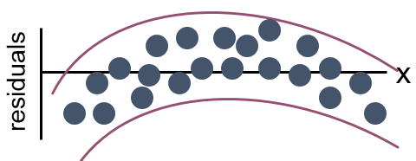

What is wrong with the following residuals for simple linear regression?
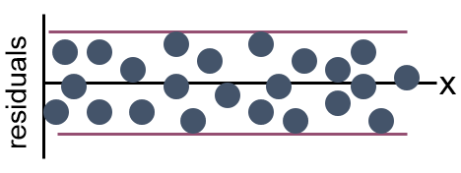

What is wrong with the following residuals for simple linear regression?
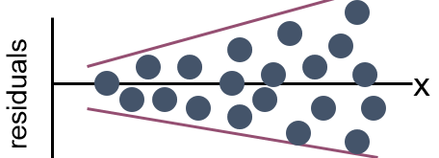

How might you model a relationship that looks like this?

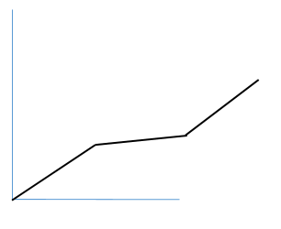

What is meant by relative risk of an event? What is meant by odds ratio?

When are relative risks and odds ratios similar? When are they quite different?

The follow code was run:
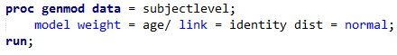
The following appears in the output:
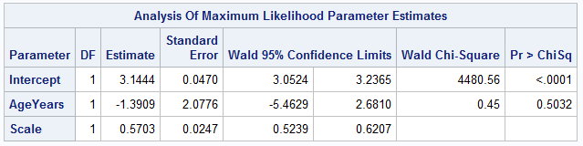

What type of regression is this?

What method was used to estimate the parameters?

Interpret the relationship of age to weight. Note that age is measured in years and weight in kg. Include a confidence interval in your interpretation.

The follow code was run:
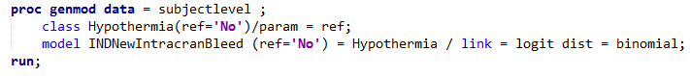
The following appears in the output: PROC GENMOD is modeling the probability that INDNewIntracranBleed='Yes'.
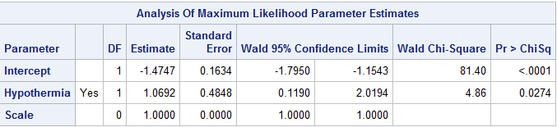

What type of regression is this?

What method was used to estimate the parameters?

Interpret the relationship of hypothermia to intracranial bleeding. Include a confidence interval in your interpretation.

The follow code was run:
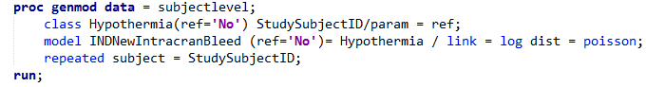
The following appears in the output:
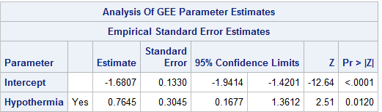

What type of regression is this? Note that the repeated statement ensures that robust estimators are used for the standard error of the estimators.

Interpret the relationship of hypothermia to intracranial bleeding. Include a confidence interval in your interpretation.

The follow code was run:
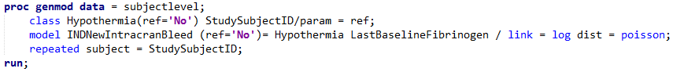
The following appears in the output:
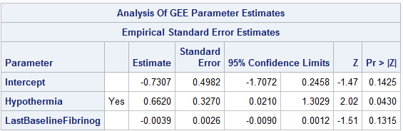

What type of regression is this? Note that the repeated statement ensures that robust estimators are used for the standard error of the estimators.

Interpret the relationship of hypothermia to intracranial bleeding. Include a confidence interval in your interpretation.

Interpret the relationship of fibrinogen to intracranial bleeding. Note that fibrinogen is reported in mg/dL.

The follow code was run:
The following appears in the output: PROC GENMOD is modeling the probability that INDNewIntracranBleed='Yes'.
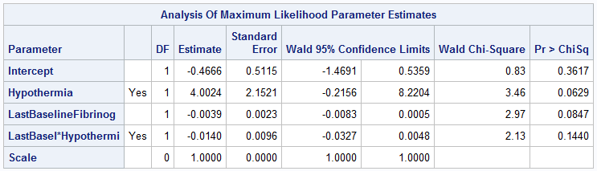

What type of regression is this?

Interpret the relationship of fibrinogen to intracranial bleeding. Note that fibrinogen is reported in mg/dL.

The following code (which uses robust error estimates) was run:
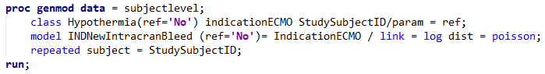
The following output was generated from the above code:
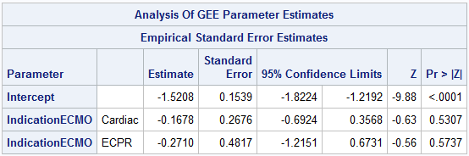
What type of regression is this?

Interpret the relationship between the indication for ECMO and intracranial bleeding. Note that indication for ECMO is a nominal variable with three levels: Respiratory, Cardiac, and eCPR.

