Given a random sample of size 10,000 with sample mean of 32 from a N(μ, 2²) population, give a 90% equal tailed confidence interval by doing the following steps. Note that z_{0.05} = -1.645.
Write an appropriate probability statement.

Rewrite the statement to isolate μ.

Write the random interval.

Write the outcome of the random interval (i.e. confidence interval)

Suppose you have a random sample of size 9 from a normally distributed population with a variance of 1/4. Find a uniformly most powerful test of the null hypothesis that the mean is zero against the alternative that the mean is less than zero. Use a significance level of 0.05. Express your answer as: Reject the null hypothesis when [test statistic] is [larger/smaller] than [threshold].

What is the power of the test if the mean is actually -1?

What is the probability of type I error if the mean is 0?

What is the probability of type II error if the mean is 0?

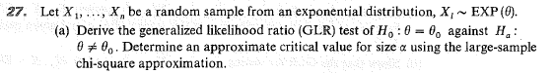
Express your answer as: Reject the null hypothesis when [test statistic] is [larger/smaller] than [threshold].

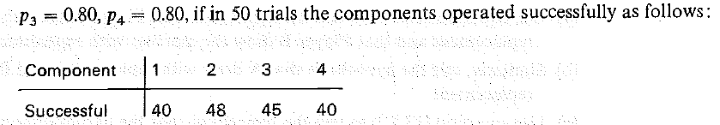
What is the expected number of successes for component 3?

What distribution does the test statistic have under the null hypothesis?

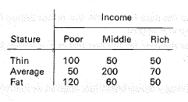
Test the hypothesis that there is no relationship between income and stature. Express your answer in terms of the p-value.
A random sample of size 2 is obtained from Population A with outcomes of 3 and 7. A random sample of size 9 is obtained from Population B with outcomes of 10¹, 10², 10³, …, 10⁹. The two samples are independent. Population A and Population B are thought to have similarly shaped distributions but with a possible shift in the mean. We will test the null hypothesis that the means are the same against the one-sided alternative that the mean is smaller in population A.
What is an appropriate test?

Compute the p-value.

The following code (which uses robust error estimates) was run:
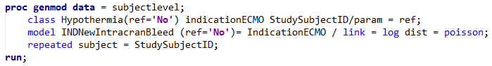
The following output was generated from the above code:
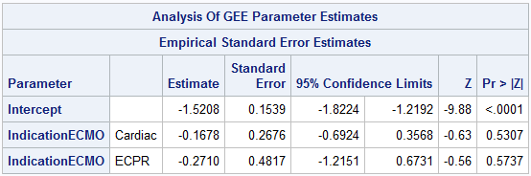
What type of regression is this?

Interpret the relationship between the indication for ECMO and intracranial bleeding. Note that indication for ECMO is a nominal variable with three levels: Respiratory, Cardiac, and eCPR.

The following code was run:
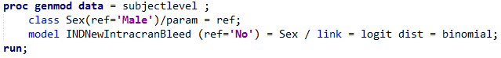
The following output was generated from the above code:
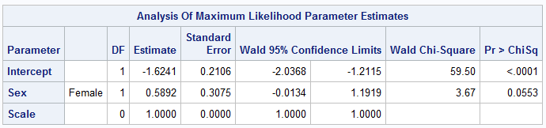
What type of regression is this?

What method was used to estimate the parameters in the model?

Interpret the relationship between the sex and intracranial bleeding. Note that sex = 1 for female and 0 for male.

The following code was run:
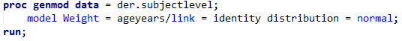
The following output was generated from the above code:
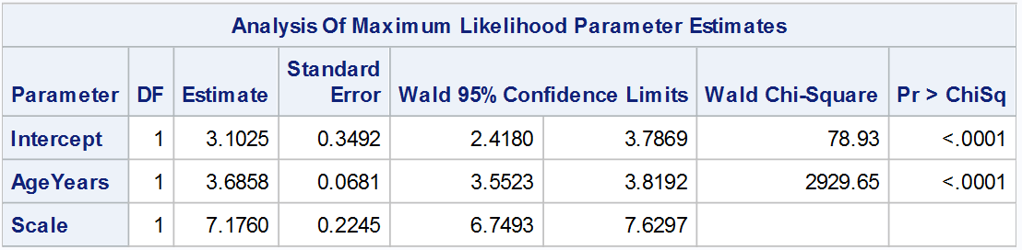
What type of regression is this?

What method was used to estimate the parameters in the model?

Interpret the relationship between the age and weight. Note that age is measured in years and weight is measured in kg (Yes, I know that kg is not actually a measure of weight).

Is the data consistent with the null hypothesis of no relationship?

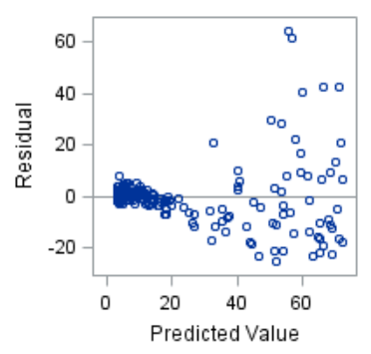
Here is a plot of the residuals. Make a wise comment.

The following code was run:
The following output was generated from the above code:
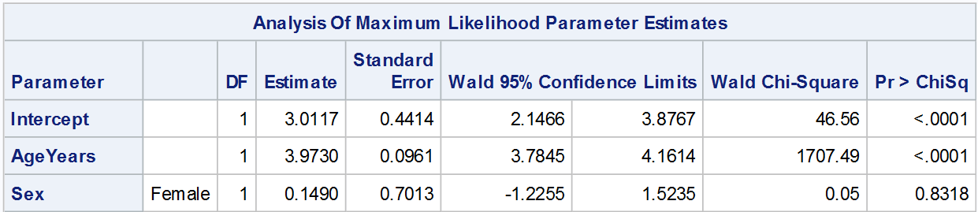
What type of regression is this?

What method was used to estimate the parameters in the model?

Interpret the relationship between the age and weight.

What is the expected weight of a 3-year-old male?

