Given a random sample of size 100 with sample mean of 2 from a N(μ, 1) population, give a 90% equal tailed confidence interval by doing the following steps. Note that z_{0.05} = -1.645.
Write an appropriate probability statement.

Rewrite the statement to isolate μ.

Write the random interval.

Write the outcome of the random interval (i.e. confidence interval)

Suppose you have a random sample of size 100 from a normally distributed population with a variance of 1. Find a uniformly most powerful test of the null hypothesis that the mean is zero against the alternative that the mean is larger than zero. Use a significance level of 0.05. Express your answer as: Reject the null hypothesis when [test statistic] is [larger/smaller] than [threshold].

What is the power of the test if the mean is actually 1?

What is the probability of type I error if the mean is 0?

What is the probability of type II error if the mean is 1?

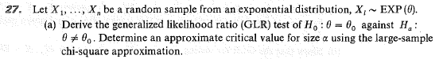
Express your answer as: Reject the null hypothesis when [test statistic] is [larger/smaller] than [threshold].

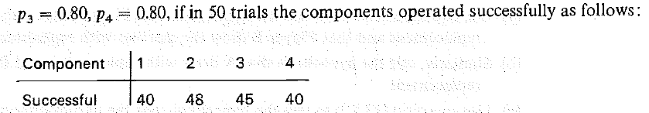
Express your answer in terms of the p-value.

With the same data, test H₀: p₁ = p₂ = p₃ = p₄. Again, provide the p-value.

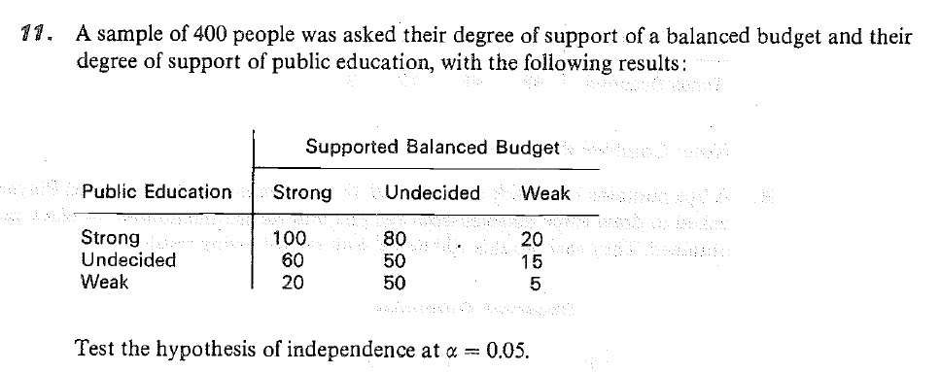
Express your answer in terms of the p-value.
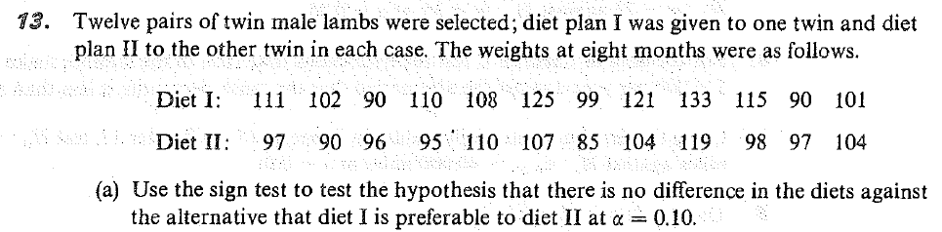
Express your answer in terms of the p-value.

A random sample of size 1 is obtained from Population A with an outcome of 3. A random sample of size 9 is obtained from Population B with outcomes of 10¹, 10², 10³, …, 10⁹. The two samples are independent. Population A and Population B are thought to have similarly shaped distributions but with a possible shift in the mean. We will test the null hypothesis that the means are the same against the one-sided alternative that the mean is smaller in population A.
What is an appropriate test?

Compute the p-value.

