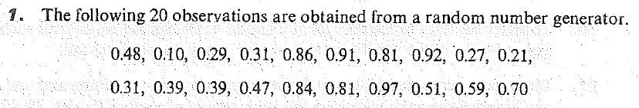

Test the null hypothesis that the 25th percentile is 0.80 against the alternative that the 25th percentile is less than 0.80. Provide the p-value in terms of a known distribution.

