Throughout this exam, put all of your answers in the boxes provided; for multiple choice questions, circle the best answer. Each page represents a stand-alone problem, but there may be multiple parts within the page. Each page is worth 2 points.
Suppose you have a normally distributed population with a variance of 1. What test statistic, with variance of 1, would make a good test for the hypotheses below?
T =

Construct a rejection region for a test of size 16% for a null hypothesis of a mean less than or equal to zero against a one sided alternative that the mean is greater than zero.

Reject the null hypothesis if the outcome, t, of the test statistic, T, is in this interval:

What is the probability of type II error if the population mean is 7?

Φ ( )

Compute the p-value if the outcome of the test statistics is 5.

Φ ( )
Suppose you have a normally distributed population with a variance of 3². What test statistic, with variance of 1, would make a good test for the hypotheses below?
T =

Construct a rejection region for a test of size 80% for a null hypothesis of a mean greater than or equal to five against a one sided alternative that the mean less than five.

Reject the null hypothesis if the outcome, t, of the test statistic, T, is in this interval:

What is the probability of type II error if the population mean is -17?

Φ ( )

Compute the p-value if the outcome of the test statistics is -5.

Φ ( )

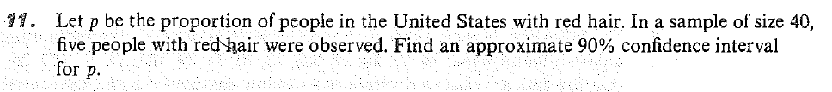

Suppose you have a population whose distribution is the two-parameter exponential with location parameter η and scale parameter θ = 1. A pivotal quantity for η is

A one-sided upper 90% confidence bound on η is

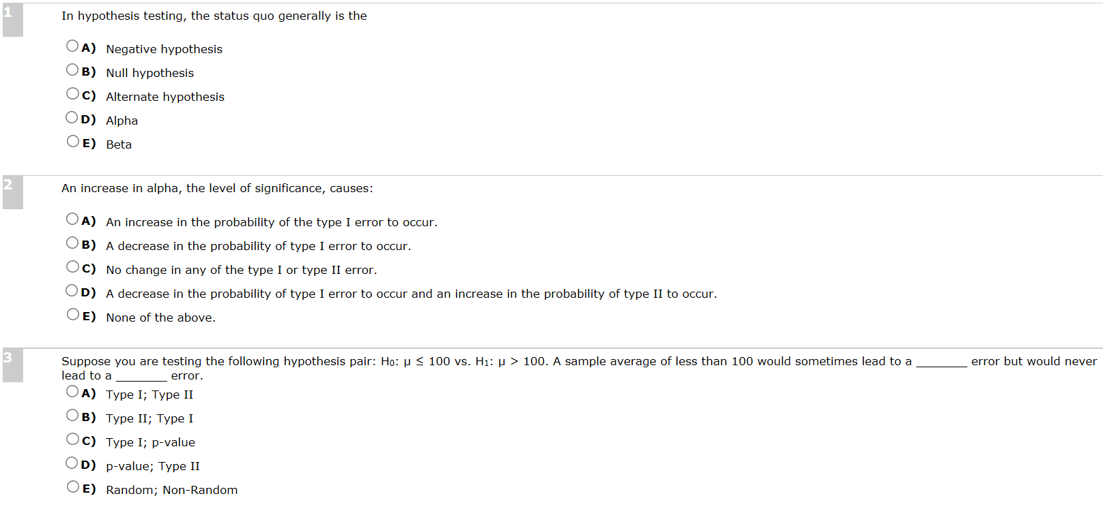

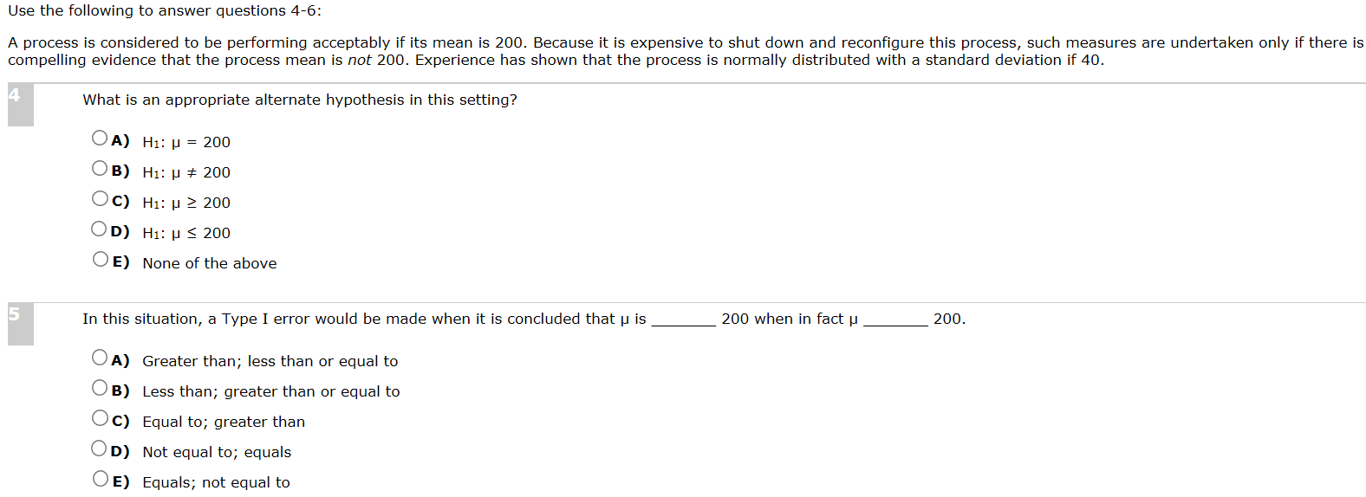

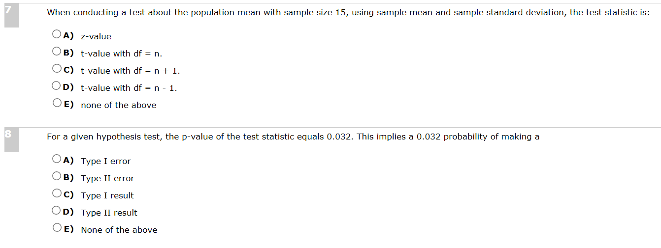

 | Patient survived to hospital discharge
High quality CPR performed | Yes | No
Yes | 2 | 1
No | 1 | 3
A multi-center observational study was recently done to assess the relationship between ‘high quality CPR’ and survival to hospital discharge. Using the contingency table below, find the p-value for Fisher’s exact test. Note the data in the table was fabricated to aid in simple hand calculation.

Write down the form of a simple linear model for the relationship between [hours per week of studying] and [Overall grade (percentage points, e.g. 78) in Math 5090].

Which term represents the outcome (dependent variable)?

Which term represents the predictor (independent variable)?

What do you think the sign of the slope will be?

Why?

How would you interpret a slope of 5 in this model?

If the intercept is 30 and the slop is 5, what score (percentage points) would you expect a student to achieve if he/she studies 7 hours per week?

Suppose the student receives a score of 80 in the class. What is the value of the residual associated with this student?

