Throughout this exam, put all of your answers in the boxes provided. Each page represents a stand-alone problem, but there may be multiple parts within the page.
Suppose you have a normally distributed population with a variance of 1. What test statistic would make a good test for the hypotheses below? (1 point)
T =

Construct a rejection region for a test of size 16% for a null hypothesis of a mean less than or equal to zero against a one sided alternative that the mean is greater than zero. (1 point)

Reject the null hypothesis if the outcome, t, of the test statistic, T, is in this interval:

What is the probability of type II error if the population mean is 7? (1 point)

Φ ( )

Compute the p-value if the outcome of the test statistics is 5. (1 point)

Φ ( )

(1 point) Suppose you have an exponentially distributed population with a mean of either 1 or 2 and you have a sample of size 10 from that population. A most powerful test of size 10% of the null hypothesis that the mean is 1 against the alternative that the mean is 2 is to reject the null hypothesis if
x̅ > .

(1 point) A uniformly most powerful test of size 10% would be to reject the null hypothesis if

x̅ > .

Suppose you have a population with a Poisson distribution. A generalized likelihood ratio test of size 5% of the null hypothesis that the mean is 12 against the 2-sided alternative is to reject the null hypothesis if

-2log(λ) > (1 points)

Where λ = (1 points)

A random sample of size 3 is obtained from Population A with outcomes of 1,2,7. A random sample of size 2 is obtained from Population B with outcomes of 4 and 40. The two samples are independent. Population A and Population B are thought to have similarly shaped distributions but with a possible shift in the mean. The p-value for a Wilcoxon rank-sum test of the null hypothesis that the means are the same against the one-sided alternative that the mean for Population A is smaller is
(2 points)
In a random sample of size 50 from the population of Utah voters, 30 prefer Hilary over Trump; 10 prefer Trump over Hilary, and 10 hate them both equally. Use a sign test to test the null hypothesis that Utahans are evenly split between favoring Hilary vs. Trump against the alternative that Hilary is preferred over Trump. The p-value is
(2 points)
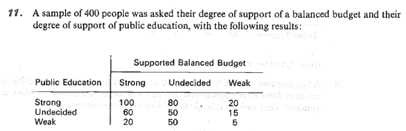

We would like to test the null hypothesis that support for a balanced budget is independent of support for public education.
Under the null hypothesis, the expected number with strong support for both is

(1 point)

Using the standard chi-squared test statistic, t, for this test, the p-value is

P ( χ²( ) ≥ t) (1 point)
Suppose you have a population whose distribution is the two-parameter exponential with location parameter η and scale parameter θ = 1. A pivotal quantity for η is

(1 point)

A one-sided upper 90% confidence bound on η is

(1 point)

