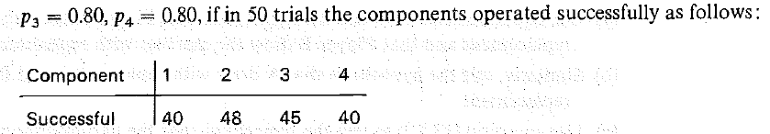
Note: you should find the p-value for this problem.

With the same data, test H₀: p₁ = p₂ = p₃ = p₄. Again, provide the p-value.

