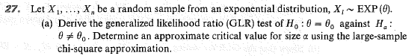

Repeat using a one-sided alternative: θ < θ₀.

