Epinephrine, also known as adrenaline, is a hormone and also a drug. It has many medical uses. One of those uses is to increase blood pressure during in-hospital cardiopulmonary resuscitation (CPR). The idea is that epinephrine increases blood pressure and higher blood pressure is associated with a higher probability of survival. We want to know whether administering a bolus of epinephrine within two minutes of the start of CPR is associated with better outcomes. Outcomes of interest are 1) return of spontaneous circulation (ROSC) and 2) survival to hospital discharge. To throw another wrench into this analysis, some subjects were already receiving epinephrine or similar medications as a transfusion at the time of cardiac arrest; the association of a speedy epinephrine bolus with outcomes may differ depending on whether similar medications were being transfused when CPR started. The ‘dose’ of similar medications is measured with the vasoactive-inotropic score (VIS). We hypothesize that a speedy epinephrine bolus for subjects with high VIS at the start of CPR will have little association with outcomes while speedy epinephrine bolus for subjects with low VIS will be associated with higher probability of ROSC and survival.
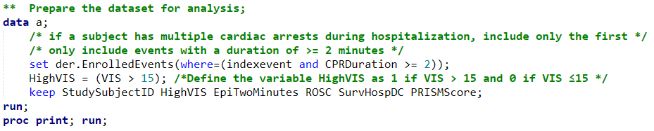
Here’s what the first 10 records in the dataset look like. I’ve excluded the StudySubjectID out of an over-abundance of caution regarding protected health information. It’s an over-abundance because the only people who would be able to link this number to, for example, the patient’s name would be hospital personnel that already know the patient’s name and health information. Recall that PRISM is a measure of illness severity, with higher scores indicating a more severely ill patient.
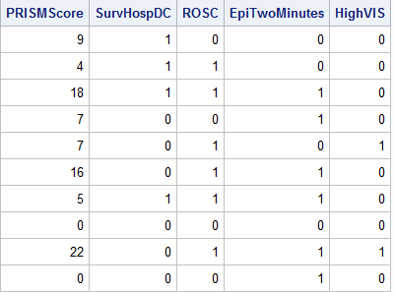
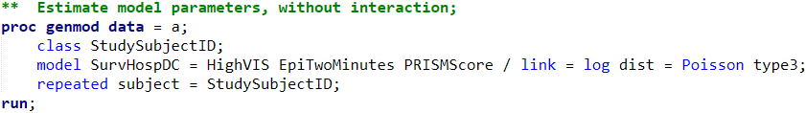
Here are the results of the model when interactions are not considered.
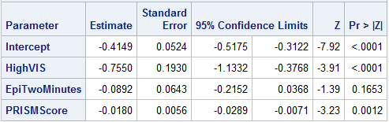
Interpret the relationship between epinephrine within the first two minutes of CPR and survival. Write a few sentences. Include an estimate, a confidence interval, and an evaluation of whether epinephrine within two minutes is associated with survival. Don’t forget that there are other variables in the model.

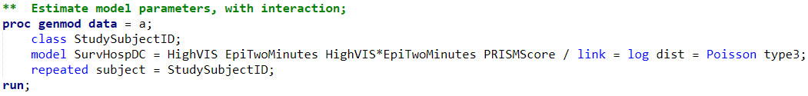
Here are the results of the model when interaction is included.
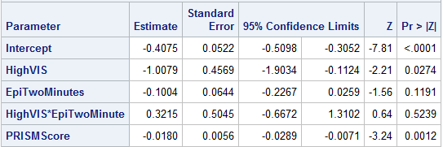
Is there clear evidence of interaction?

Regardless of whether there is or is not evidence of interaction in this data, the literature suggests (I’m making this up) that this interaction exists. A large p-value could simply be due to an insufficient sample size. Therefore, we will interpret this model with the interaction included. Interpret the relationship between epinephrine within the first two minutes of CPR and survival. Write a few sentences. Include an estimate for subjects with high VIS and an estimate for subjects without high VIS. For one of these estimates, you have enough information to report a confidence interval and an assessment of whether epinephrine within 2 minutes is associated with survival; in that case, include these in your interpretation. For the other one of these, you will not have enough information, so do not include these.

Based on this model, what is the estimated probability of survival for the first 3 subjects in the dataset?

What can you say regarding our initial hypothesis? We hypothesized that a speedy epinephrine bolus for subjects with high VIS at the start of CPR would have little association with outcomes while speedy epinephrine bolus for subjects with low VIS would be associated with higher probability of ROSC and survival.

