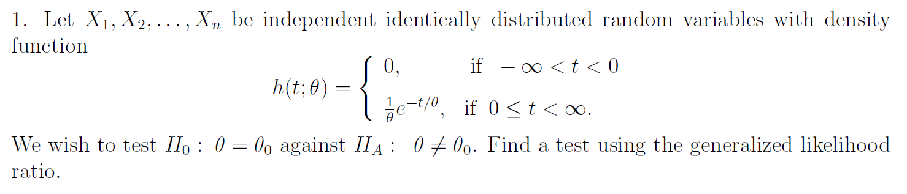
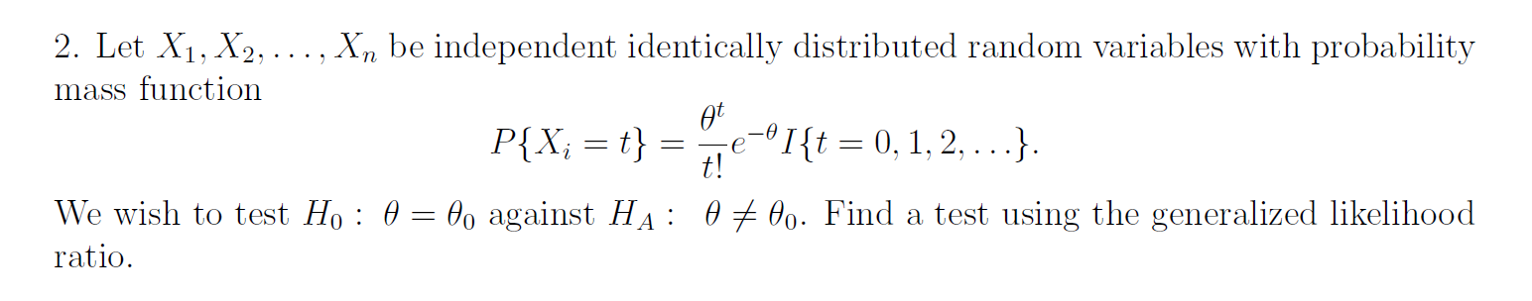
Consider a random sample of size 37 for N(μ₁, 1) and another, independent random sample of size 51 from N(μ₂, σ²). Construct a test of the null hypothesis that μ₁ = μ₂ against the two-sided alternative using the generalized likelihood ratio. Write down an expression for the p-value in terms of an appropriate distribution.

Consider a random sample of size 37 for N(μ₁, σ²) and another, independent random sample of size 51 from N(μ₂, σ²). Construct a test of the null hypothesis that μ₁ = μ₂ against the two-sided alternative using the generalized likelihood ratio. Write down an expression for the p-value in terms of an appropriate distribution.

