1a. Suppose that the number of defects in a piece of wire of length t yards is POI(λt) and that one defect is found in a 100-yard piece of wire. Find the p-value of an exact of the null hypothesis that λ ≥ 0.05 against the alternative that λ < 0.05.

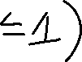

1b. Now suppose that another piece of wire (300 yards in length) is found to have 5 defects. Find the p-value based only on the second wire and also find the p-value if the data from the two wires were combined.

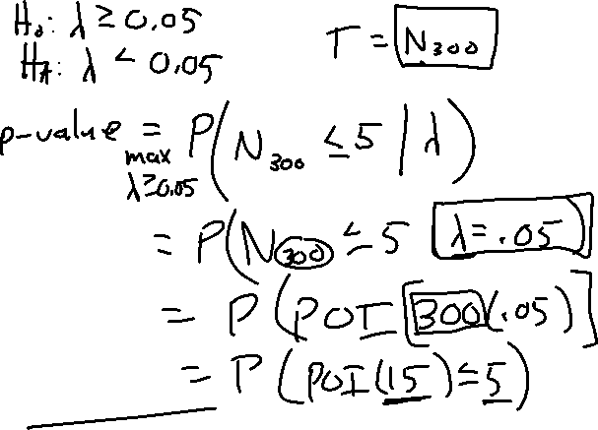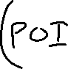

1c. Repeat 1a with an approximate test. Is the approximate test conservative?

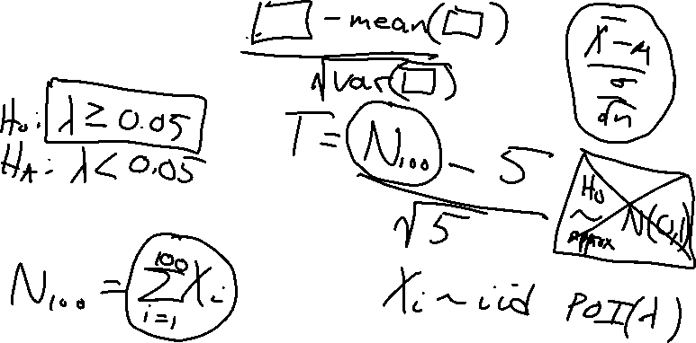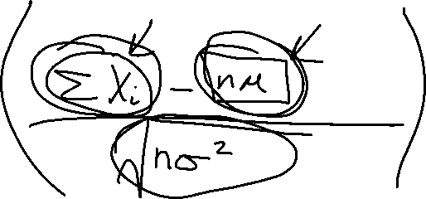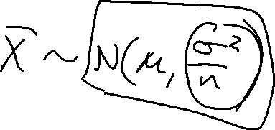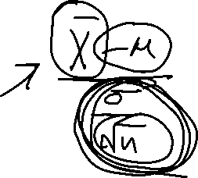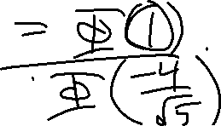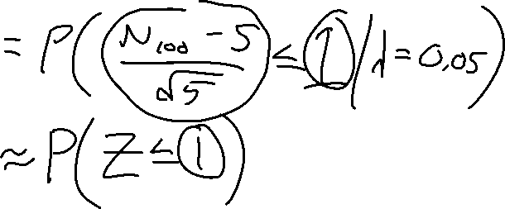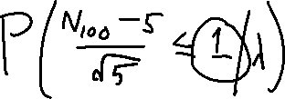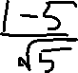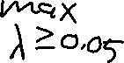

1d. Repeat 1b with an approximate test.