The follow code was run:
The following appears in the output: PROC GENMOD is modeling the probability that INDNewIntracranBleed='Yes'.
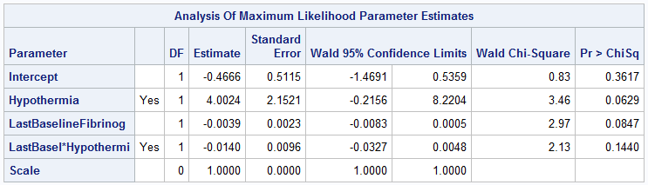

Interpret the relationship of fibrinogen to intracranial bleeding. Note that fibrinogen is reported in mg/dL.

PRISM is a measure of illness severity when a child is admitted to an intensive care unit. Age is a categorical (nominal) variable with 4 levels. Interpret the association of PRISM with mortality among neonates. Repeat the interpretation among infants. You may notice that there’s really not a lot of interaction here. We’ll assume that the analysis was prespecified to include an interaction term, regardless of the amount of interaction observed.
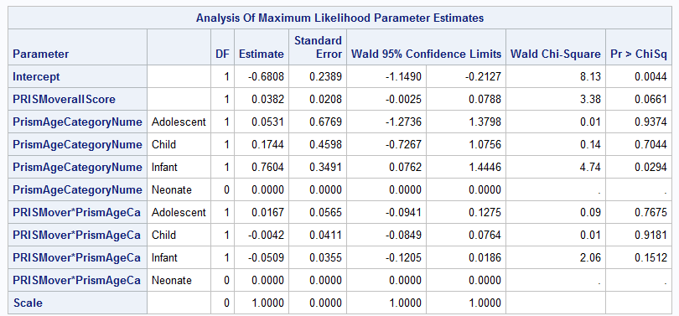

Consider the previous example but use Age as a continuous rather than categorical variable. This is a sad example indeed due to the extremely limited interaction. This is also probably an inappropriate way to model age in a pediatric cohort. But we’ll press forward in this academic exercise. Ignore the fact that many parameters could plausibly be zero. What is the association of PRISM with mortality for 3-year-olds? For 17-year-olds?
