Ordinary linear regression

Write a sentence in which you interpret the slope. Include the confidence interval in your sentence.
proc genmod data = der.subjectlevel;
model DisTotalFSS = EcmoDurationWeeks / link = identity dist = normal;
run;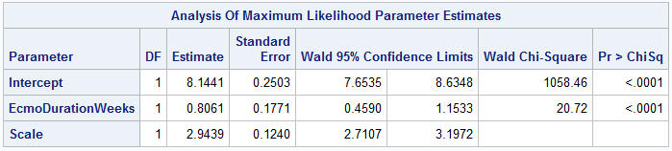
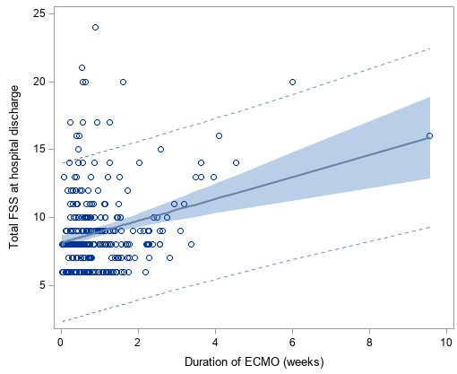
FSS increase, on average, by 0.8061 (95% CI: 0.4590, 1.1533) for each additional week of ECMO.

Ordinary linear regression

Write a sentence in which you interpret the slope. Include the confidence interval in your sentence.
proc genomd data = der.subjectlevel;
model DisTotalFSS = PRBC24 / link = identity dist = normal;
run;
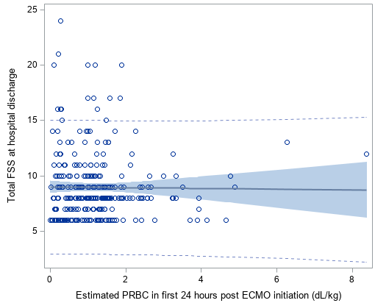
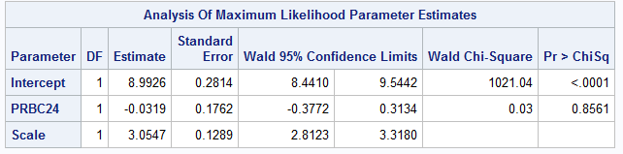
FSS at hospital discharge decreases, on average, by 0.0319 (95% CI: -0.3134, 0.3772) for each additional dL/kg of packed red blood cells transfused in the first 24 hours after ECMO initiation.

Logistic regression

Write a sentence in which you interpret the odds ratio. Include the confidence interval in your sentence.

proc genmod data = der.subjectlevel plots = all;
model dead(event='Yes') = EcmoDurationWeeks / link = logit dist = binomial;
run;
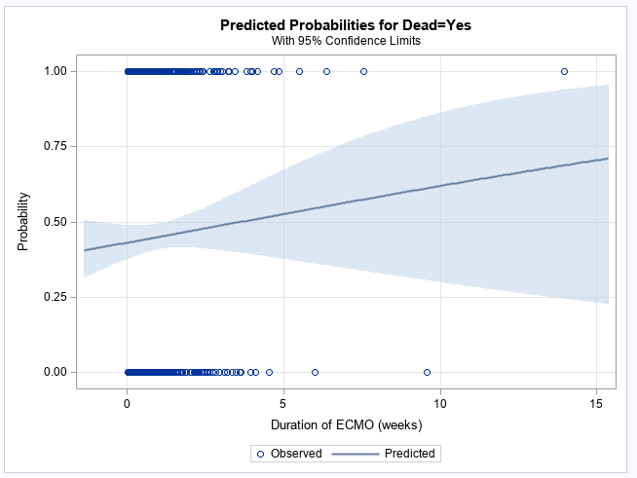
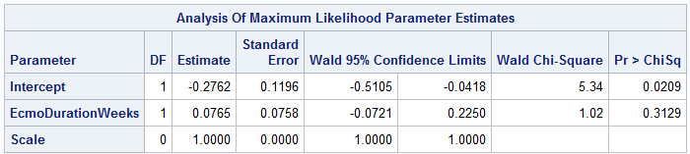

Logistic regression

Write a sentence in which you interpret the odds ratio. Include the confidence interval in your sentence.

proc genmod data = der.subjectlevel plots = all;
model dead(event='Yes') = PRBC24 / link = logit dist = binomial;
run;
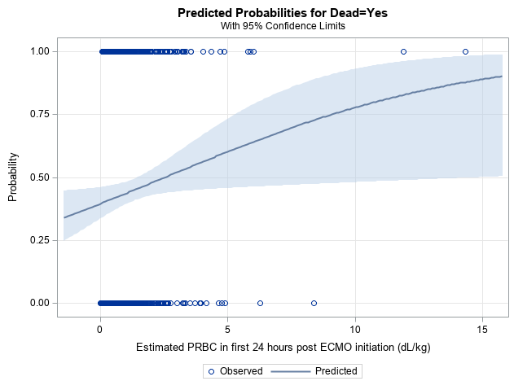
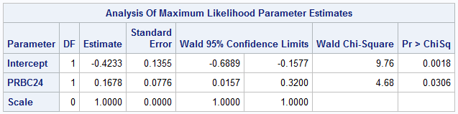

Poisson regression with robust error estimates (aka modified Poisson regression)

Write a sentence in which you interpret the relative risk (aka the risk ratio). Include the confidence interval in your sentence.

proc genmod data = der.subjectlevel;
class StudySubjectID;
model dead = EcmoDurationWeeks / dist = Poisson link = log;
repeated subject = StudySubjectID;
run;
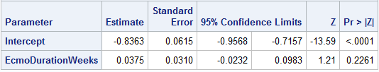

Poisson regression with robust error estimates (aka modified Poisson regression)

Write a sentence in which you interpret the relative risk (aka the risk ratio). Include the confidence interval in your sentence.

proc genmod data = der.subjectlevel;
class StudySubjectID;
model dead = PRBC24 / dist = Poisson link = log;
repeated subject = StudySubjectID;
run;
