Failure times in hundreds of hours for air conditioners in two different airplanes are listed below. Test the null hypothesis that the distribution of failure times are the same against 1) the alternative that air conditioners in Airplane 1 tend to last longer 2) the alternative that air conditions in Airplane 2 tend to last longer, and 3) the distribution of failure times are different.

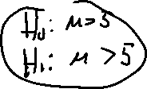

Airplane 1: 1,5,5,8

Airplane 2: 2

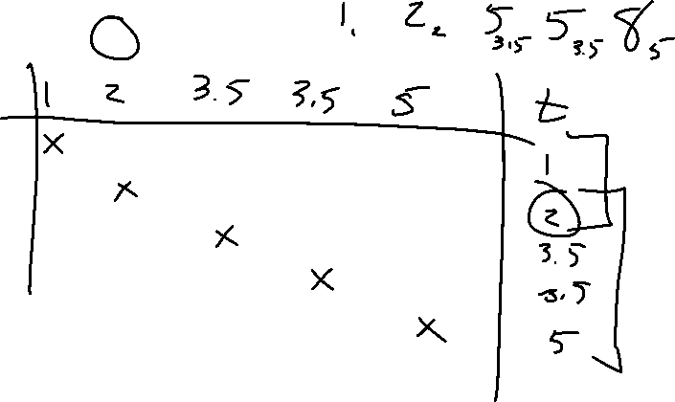

Repeat the problem with this set of data:

Airplane 1: 1,5

Airplane 2: 3,700

Repeat the problem with this set of data:

Airplane 1: 1,5,5,8,12,20,22,23,25

Airplane 2: 30,50,88

