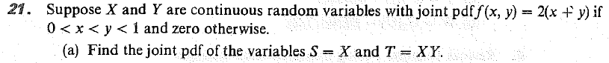

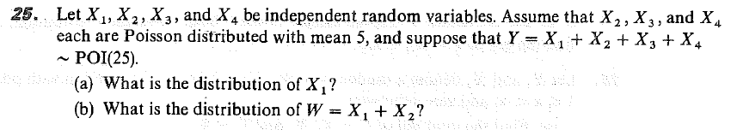

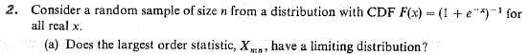

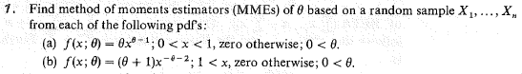

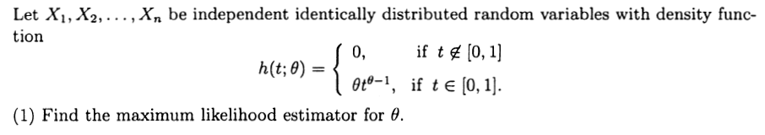

This is a continuation of the problem on the previous page.
Find a UMVUE for the unknown parameter and explain how you know it is a UMVUE.

Explicitly state the non-zero function, u(x), used to show that it is not complete.

Is the following family a member of the REC? Explain.

