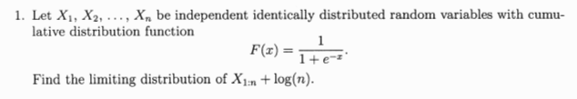

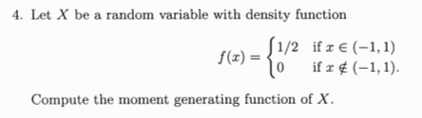

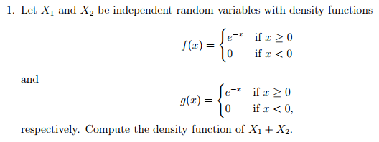

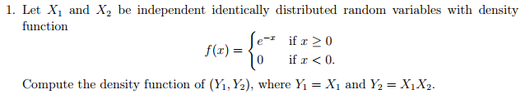

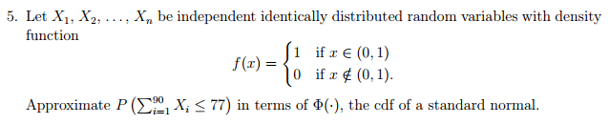

If X is normally distributed with mean 3 and variance 7², what transformation will yield a uniform(0,1) distribution?

Does convergence in probability imply convergence in distribution?

Does convergence in distribution imply convergence is probability?

