- Fall 2014, Exam 1, page 1
- Fall 2014, Exam 1, page 4
- Spring 2015, ConvolutionFormula5
- Spring 2015, exam1, page 1
- Spring 2015, exam1, page 5
- Similar to Spring 2015, exam1, page 6
- Spring 2015, Jan 22

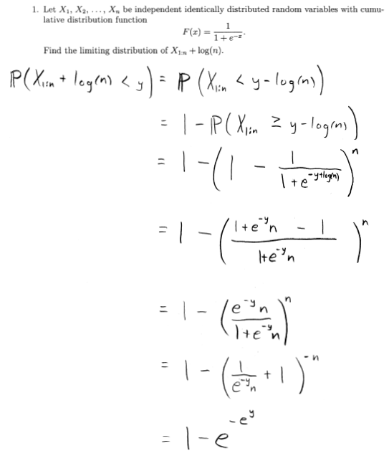

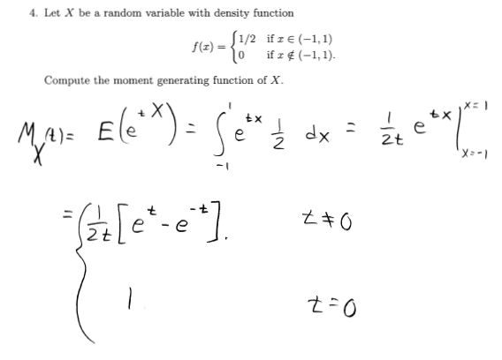

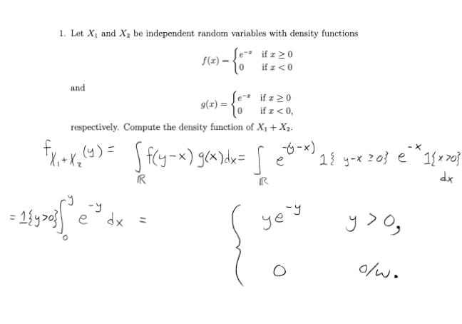

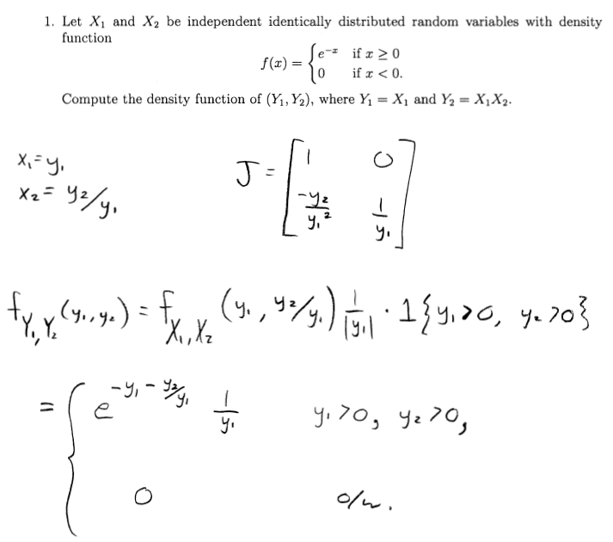

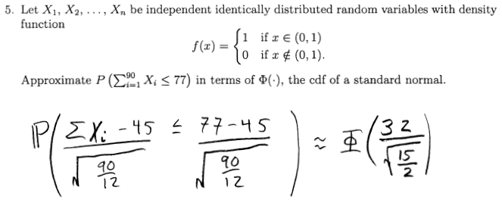

If X is normally distributed with mean 3 and variance 7², what transformation will yield a uniform(0,1) distribution?

Φ((X-3)/7)

Does convergence in probability imply convergence in distribution?

Yes.

Does convergence in distribution imply convergence is probability?

No.

