Name:
Quiz 15, Attempt 1
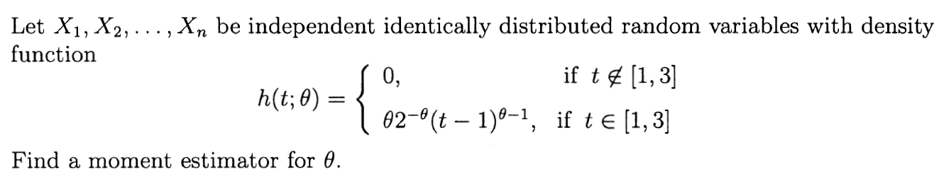

Quiz 13, Attempt 2
Read this instruction: Cross out the statements that are false.
The sum of independent chi-squared random variables is chi squared, even if they each have a different number of degrees of freedom.
The square of a standard normal random variable has a chi-squared distribution with 1 degree of freedom.

