Name:
Quiz 12, Attempt 1
If X and Y are i.i.d. N(5,2), what is cov(X+Y, X-Y)?

E[(X+Y)(X-Y)]?

Quiz 10, Attempt 2
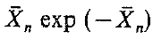
Find the asymptotic normal distribution of

