Name:
Quiz 11, Attempt 1
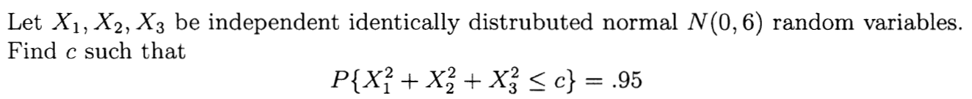
Express your answer in terms of a percentile for a distribution that we know. For example, the 15th percentile of a χ²(7) is written as χ²_{0.15}(7).

Quiz 9, Attempt 2
