Name:
Quiz 9, Attempt 1
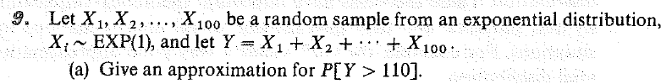

Quiz 7, Attempt 2
Find the density function of the largest order statistic based on a random sample of size n from an EXP(1) population (Homework #8.31b).

