Name:
Quiz 08, Attempt 1
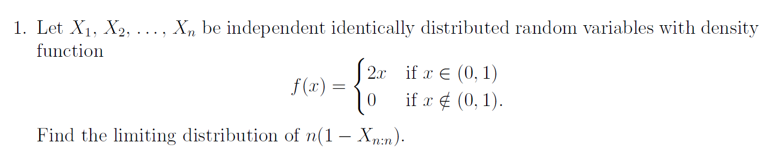

Quiz 6, Attempt 2

