Name:
Quiz 6, Attempt 1
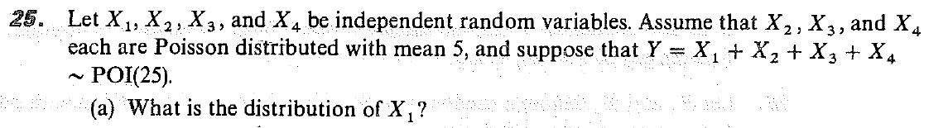

Quiz 4, Attempt 2 (Homework 8a)
Find the distribution of X⁴ using the transformation method if X has the following density function:

