Name:
Quiz 5, Attempt 1
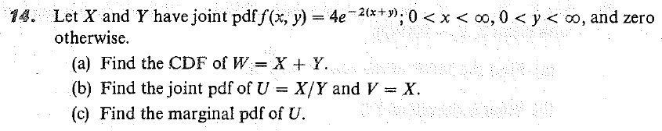

Quiz 3, Attempt 2 (borrowed from 2019, quiz 4, attempt 1)
Suppose X is exponentially distributed with a mean of 3 and Y is uniformly distributed on the interval from 2 to 4. Assuming X and Y are independent, find the density function of their sum.

