Name:
Quiz 3, Attempt 1
Find the density of the sum of two independent, exponentially distributed random variables with means of 3 and 7.

Quiz 1, Attempt 2
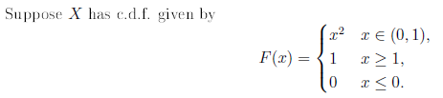
Find the second moment of X, i.e. E(X²).

